GuIDe

PRO

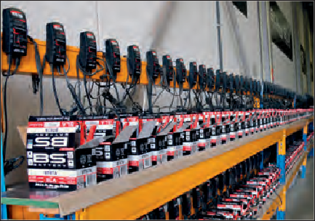New EU acid regulation – BS ready to use SLA/SLA MAX batteries

With new European regulations on acid handling and shipping coming into effect in 2021, BS Battery says it has already been getting ready to make sure its customers are compliant with its "full ready-to-use battery range", which doesn’t require maintenance and acid handling, according to General Manager Benjamin Sebban.

"We have been developing innovative solutions of many kinds for several years and our ready-to-use batteries have already built a strong reputation around the world." Designed specifically for powersports applications, BS battery ranges such as its SLA and SLA Max are ready-to-use batteries that are said to offer "plenty of benefits such as high performance, increased power, extended life, extreme vibration resistance and multi-positional fitment".

Approved as OE equipment by many of the

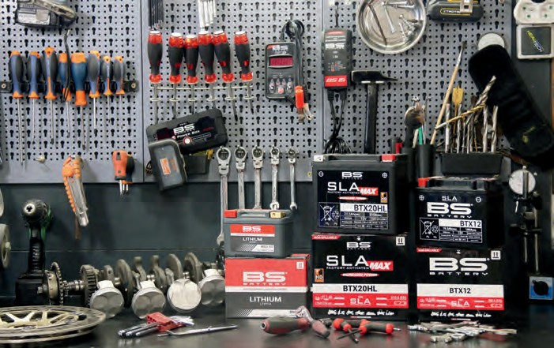

leading global motorcycle manufacturers, BS Battery says it has the widest range of ready-to-use batteries, with more than 80 sealed, ready to use and pre-charged motorcycle battery applications in stock and ready to ship.

"We had already upgraded our dry maintenance-free battery range to SLA and SLA Max ready-to-use technology simply because they are better - better performance, greater durability, much easier to use with no acid handling and maintenance.

"Now, with the new regulations, BS Battery is in the perfect position to help distributors and their dealers to stay ahead and stay smart.

“We already meet the new European standard - our SLA and SLA Max batteries really are the best solutions for dealers and

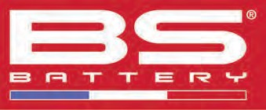

end users as they take away the increasingly unpopular complexities of dealing with acid fill technology. They are designed to make life easier for users, dealers and distributors.

"Because our batteries are already factory- activated, we are able to ensure that every day we have the right products in stock and ready to ship from our European Logistics Centre because they are maintained, tested, recharged and under control all the time." Compatible with SLA and SLA Max batteries, the BS15 charger "optimises lead acid battery power and life with microprocessor control, with no risk of overcharging, as does our BS60, a pro-smart battery charger, and the BK15, an automatic bank charger designed for professionals".

BS BATTERY SAS

Paris, FRANCE

Tel: +(33) 1 83 62 45 60

[sales@bs-battery.com](mailto:sales@bs-battery.com) [www.bs-battery.com](http://www.bs-battery.com/)

WRP tapered handlebars

Italian specialist WRP (Works Racing Parts) was founded in 1999 with the clear objective "to develop quality parts and accessories for professional riders and demanding motorcyclists who are constantly looking for greater performance".

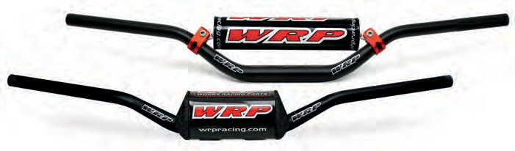To accomplish this mission, WRP invests in technology, marketing and sponsorships - WRP riders and teams compete in the FIM MotoGP/Moto2, Superbike/ Supersport, Motocross/ MXGP,

Supermoto world championships and in the USA in the AMA Supercross and Motocross championships. Seen here is what the company says is "one of the strongest and lightest handlebars available on the market. WRP tapered handlebars are used by top Motocross teams competing in the MX World Championship such as Team SM Action Yamaha, Team Assomotor Honda and others"

"The 2020 WRP racing season has seen an amazing third place in MX2 World Championship standing,

conquered by SM Action Yamaha's French rider Maxime Renaux".

Made from 7075-T6 alloy, these WRP tapered handlebars feature 28.6 mm oversized tubing in the clamping area. "The tapered design ensures they will withstand the hardest crashes, while still offering a perfect flex ratio. Every WRP handlebar is shot-peened and finished with anodising for increased surface hardness - the left grip area is knurled to prevent slipping".

They come complete with an injected polyurethane pad covered by a shiny sub-surface printed vinyl clear sheet and are available in several different bends and colours.

WIND TRADING SRL

Ravenna, ITALY

Tel: +39 0544 64024

[windtrading@windtrading.it](mailto:windtrading@windtrading.it) [www.wrpracing.com](http://www.wrpracing.com/)

**50 INTERNATIONAL DEALER NEWS - DECEMBER 2020 / JANUARY 2021** [**www.idnmag.com**](http://www.idnmag.com/)