GuIDe

PRO

BS Battery extends its 'Smart Accessories' line

French battery manufacturer BS Battery continues to invest in smart testing solutions by extending its battery condition indicator lines with the new BT 03. Designed for professionals and end-users, the new BT 03 allows dealers and riders to check the state of charge of 12V lead acid batteries, with a three integrated LED lights display diagnostic tool. Extra slim, the accessory is ideal if your battery is difficult to access, hidden or if you cannot use clamps because of the eyelet terminals.

"Making the life easier for workshops and end-users is one of our priorities," says Benjamin Sebban, BS Battery General Manager. "From the installation to the diagnostic, our new BT 03 battery tester performs a very quick check of a powersport vehicle's charging system."

Compatible with all the BS smart chargers, the BT 03 also allows to charge and maintain batteries without disconnecting the fused ring. "Connect, test, charge and forget," says Benjamin.

This new solution completes the wide range of accessories developed by BS Battery - a comprehensive range that includes the BST 50, a specialised advanced battery and electrical diagnostics tool for batteries in the 7V to 30V range

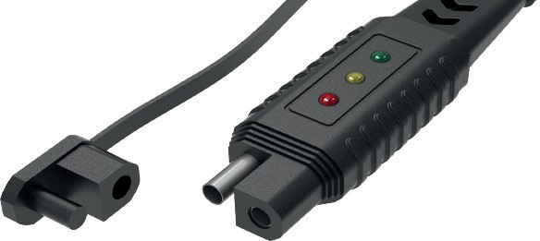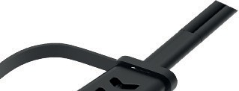

that delivers results within one second, and the BT02, a dual-purpose, simultaneous battery and alternator condition tester.

"Compatible with all lead-acid batteries, our testers are ideal during the winter season - or any period when the battery is not being used or charged frequently. They are the quick, efficient and convenient solution for checking battery status at any time," added Benjamin.

**BS BATTERY SAS**

**Paris, FRANCE**

**Tel: +(33) 1 83 62 45 60**

[**sales@bs-battery.com**](mailto:sales@bs-battery.com)[**www.bs-battery.com**](http://www.bs-battery.com/)

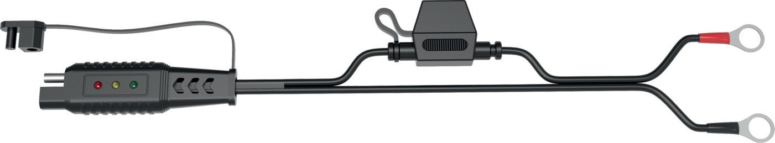

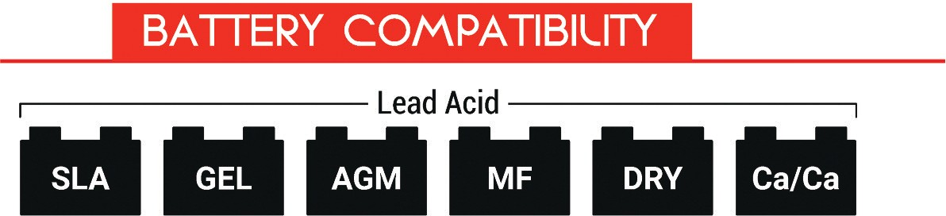

[**www.idnmag.com**](http://www.idnmag.com/)

**INTERNATIONAL DEALER NEWS - JUNE/JULY 2022 XX**