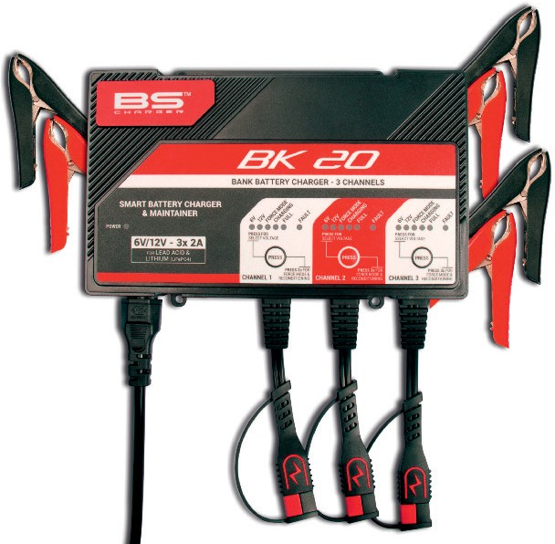Versatile new battery multi-charging station for dealers

BS Battery has responded to the increasing demand for SLA (Sealed Lead Acid) battery technology in the motorcycle, scooter and wider powersports markets by developing a new 'pro-grade' battery charging station for its dealers.

The all-new BK 20 charger and its accessories is "an essential tool for BS dealers as they can fix one to two BK 20 chargers onto a BS display, meaning that professionals will be able to store, activate, charge, maintain and recharge all batteries before installing, shipping or selling".

Designed with an advanced microprocessor, the all- new BK 20 is a 6V and 12V automatic smart battery charger and maintainer rated at 2A with battery capacity up to 40Ah - enabling it to charge and

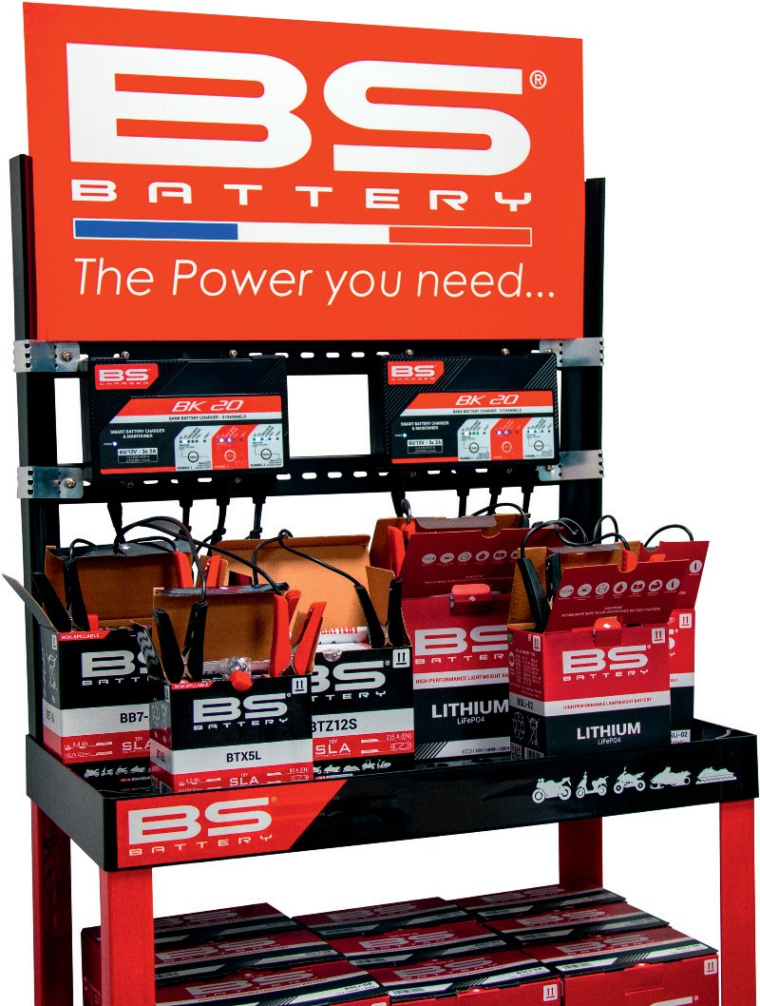

maintain three batteries with different voltages and technologies simultaneously. It includes an exhaustive charging programme with two selectable modes and nine charging steps.

The reconditioning function is also a valuable and versatile additional feature for shop use as “dead” lead-acid batteries or low voltage lithium batteries can be reactivated or restored. Described as "effective and powerful", the BK 20 is designed to "ensure optimal charging performances for all powersport battery technologies, with a 6V/12V switch mode," according to founder and CEO Benjamin Sebban.

“The all-new BK 20 is also one of the most powerful BS chargers that is able to deliver high charging current and high battery capacity - enabling dealers to charge and maintain all battery sizes. The BK 20 and its component parts make life easier for our dealers as it saves loading time of batteries and charges different battery types.This big improvement is ideal for our network and offers a new, modern and efficient way to charge and maintain batteries safely."

**BS BATTERY SAS**

**Paris, FRANCE**

**Tel: +(33) 1 83 62 45 60**

[**sales@bs-battery.com**](mailto:sales@bs-battery.com)[**www.bs-battery.com**](http://www.bs-battery.com/)