New generation BS smart chargers

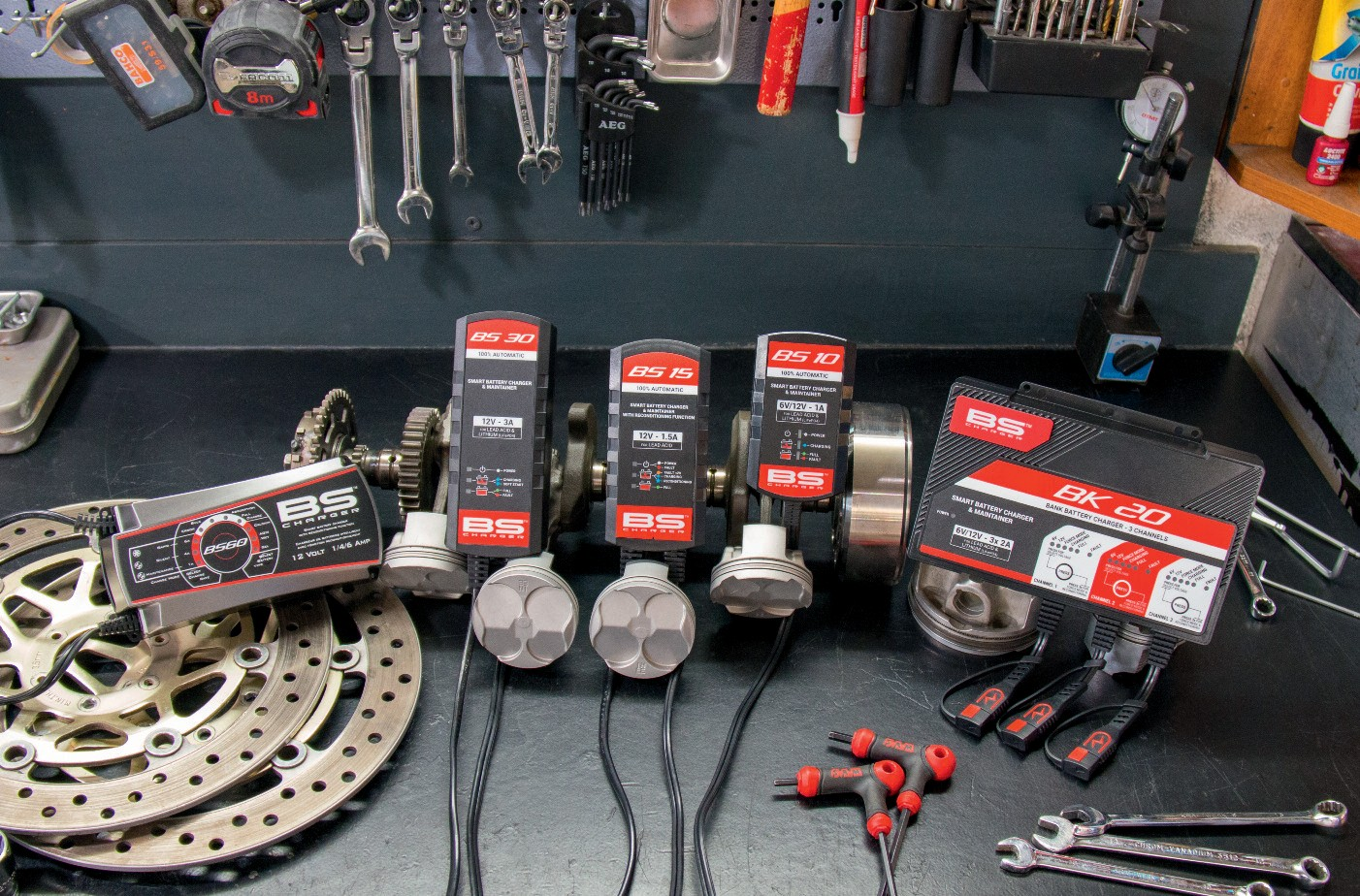

With more than 10 years' experience in the battery industry, BS Battery has always offered battery chargers to its dealer network in order to help them and their customers to get activated, charge, maintain and recharge their batteries - BS and all brands.

After many years working closely with OEM manufacturers to develop OE batteries (lead acid, more recently, Lithium), BS Battery has gathered a lot of information from manufacturers' engineering teams concerning their battery performance and specification requirements.

That knowledge and experience can now be 'money in the bank' for BS Battery dealers with an upgraded BS charger line that "is ideal for OEM manufacturers and end users".

Designed with advanced microprocessors, BS says its new chargers are 100% automatic, with the new range comprising five models - BS10, BS15, BS30, BS60, BK20 - all with two selectable modes and nine steps of charge.

The all-new BS charger BS 10 now replaces the established BA 10 and becomes a 6V and 12V smart battery charger and maintainer rated at 1A with battery capacity up to 20Ah.

"Small, safe and easy to use, this charger is one of the most practical chargers that we ever made," says General Manager Benjamin Sebban. "It will always provide a good charge and be able to recover discharged batteries."

Also compatible with lead acid and lithium batteries, BS 30 and BK 20 are two new BS smart chargers that offer a high charging current with high battery capacity. "An exhaustive charging programme has been developed into these two battery chargers to enable them to charge and maintain all battery sizes. "With a multi-axis hook, the BS 30 is a new 12V

smart battery charger and maintainer, which can be hung anywhere. With a charging current of up to 3Ah, the BS 30 is also able to work with battery sizes up to 60Ah and up to 120Ah for maintenance." Mainly developed for warehouses and garages, the BK 20 is a new smart bank battery charger and maintainer, which offers three channels of charge. Described as "the new 3 in 1 solution for professionals", the BK 20 becomes "an essential tool as it can charge and maintain three batteries with different voltages and chemistries simultaneously," says Benjamin. "The new BK 20 is designed to save time, and our distributors can fix it onto a BS display with assembly parts - meaning you can charge batteries easier."

The BS 15 and BS 60 have been kept in the BS range

- compatible with all 12V lead acid batteries; both provide a reconditioning function.

"Safe and easy to use, a 6V/12V switch mode has also been integrated into several BS chargers - BS 10, BS 30 and BK 20. It enables selection of the battery voltage you need. All BS smart chargers are ideal to enhance the performance and lifetime for all powersport battery technologies."

**BS BATTERY SAS**

**Paris, FRANCE**

**Tel: +(33) 1 83 62 45 60**

[**sales@bs-battery.com**](mailto:sales@bs-battery.com)[**www.bs-battery.com**](http://www.bs-battery.com/)

