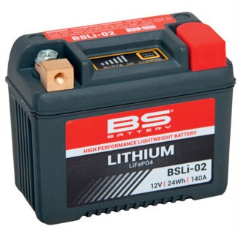BSLi-02 BS lithium battery – "The new powersports market reference-point"

BS Battery has been investing heavily in all racing activities since 2017, expanding its technical sponsorship and R&D programmes in road race, enduro and rally racing - "all the most demanding disciplines and the harshest of conditions," says General Manager Benjamin Sebban.

"I think it is now possible to say that the BS Battery line-up is firmly established as an industry reference- point throughout the international powersports market.

"For us, after many years of development work and cooperation with many of the leading vehicle makers, we have decided to invest the very specific results of our research and development in the lithium battery sector.

"We have developed a unique, ultra-resistant casing and ultra-robust terminals to make sure our batteries can be used in the most extreme conditions. Because our DNA is in racing, we know the demands that the racing environment places on batteries and now have the most advanced real- world solutions to make our BSLi-02 BS lithium battery the most robust, reliable and durable available.

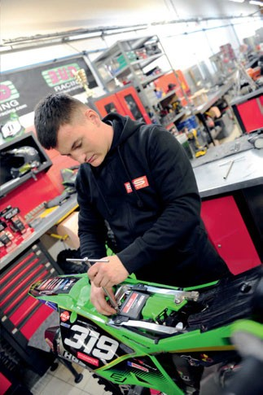

"The BS lithium BSLi-02 has a unique design with robust brass terminals and a composite fibre material case that can resist up to -230 degrees C. These batteries are a waterproof design, are lightweight and have an extensive life cycle covering most of the existing circulating park fitments with 12 models in the range."

Approved, validated and used by many teams, such as GMT94 Yamaha Team (WorldSSP), Sherco Racing Factory Team (Rally - Enduro) and the Monster Energy Yamaha Rally Team, BS lithium batteries are "developed for the most demanding riders - those who are looking for higher performance, high resistance and longer life".

In 2022, BS Battery has continued the expansion of its sponsorship programme with a new partnership with Kawasaki Bud Racing - the well-known French MX team - as its Official Technical Sponsor. "Validated and homologated by Kawasaki Bud Racing engineers, BSLi-02 will also be used by the KX450 and KX250 models in the 250 cc European Championship and other international motocross races".

**BS BATTERY SAS**

**Paris, FRANCE**

**Tel: +(33) 1 83 62 45 60**

[**sales@bs-battery.com**](mailto:sales@bs-battery.com)[**www.bs-battery.com**](http://www.bs-battery.com/)

