SLA - plug & play solution

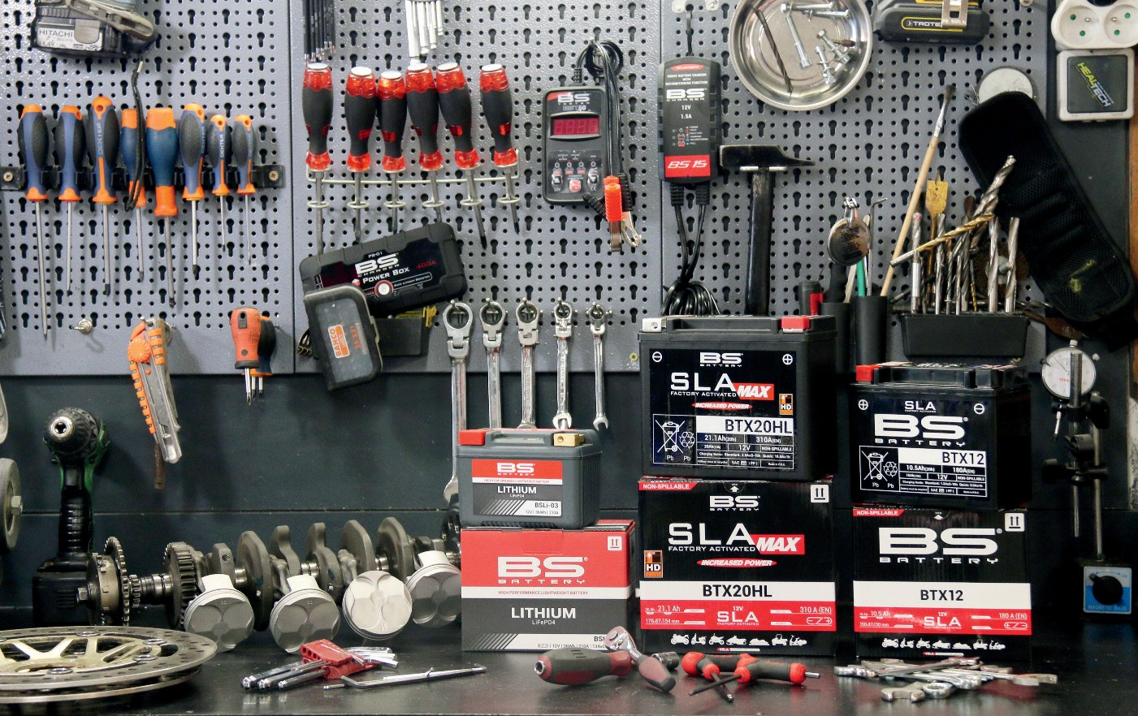

The first manufacturer to develop a complete alternative solution to conventional and maintenance- free batteries, French company BS Battery is "leading the market with more than 80 types of sealed, activated and ready-to-use batteries

- that's the BS Battery 'Plug and Play' solution". "Designed to make life easier for users, dealers and distributors, the 'Plug and Play' solution takes away all the unpopular complexities of dealing with acid - BS SLA batteries are 100% safe to use and work with," says BS Battery General Manager Benjamin Sebban.

"To ensure the optimal lifetime and performance of BS SLA batteries, our European Logistics Centre daily maintains, tests, recharges and controls all batteries before shipping. Compatible with SLA, SLA Max and Lithium batteries, our smart BS chargers - BS10 and BS30 - run safely, precisely and powerfully 24 hours a day, 7 days a week.

"They are designed with a patented microprocessor that can optimise lead acid and lithium battery power

and durability. We can also provide our dealers with our new BK20 - an automatic bank charger, so that they can build their own charging room." Monitoring the market regulations closely (ref. to EU 2021 acid handling), Benjamin says that the BS Battery product team is "working to provide the most innovative solutions for our 80-country worldwide network. We are also accelerating our commitment to upgrade all dry and maintenance- free battery ranges to SLA and SLA Max ready-to-use technology simply because they are safer, stronger and more powerful."

BS Battery just released a complete range of 6V batteries in SLA version that would be ideal for restoration of older bikes and classic vehicles.

**BS BATTERY SAS**

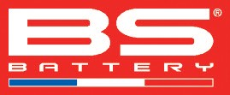**Paris, FRANCE**

**Tel: +(33) 1 83 62 45 60**

[**sales@bs-battery.com**](mailto:sales@bs-battery.com)[**www.bs-battery.com**](http://www.bs-battery.com/)