BST 1000 - "a complete battery testing programme"

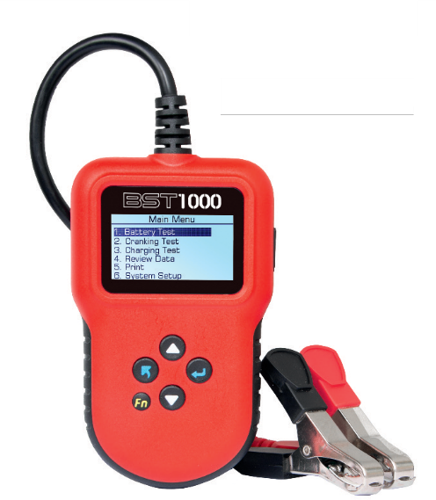

Paris, France based BS Battery says that "having a comprehensive analysis of the battery’s lifespan is crucial for the professionals who want to provide the best services possible for their clients - crafting useful solutions for workshops is one of the priorities of BS Battery."

The French manufacturer is a prolific new product designer which, it says, is a result of its "close collaborations with the technical engineers at the racing teams and motorcycle brands we support and supply.

"Our brand-new BST 1000 is a 12V lead acid and lithium battery tester that offers a complete testing programme: battery test, cranking test, charging test and even report printing. Our BST 1000 is a good way to check the entire health of a motorcycle (and automotive) battery in a short period of time.

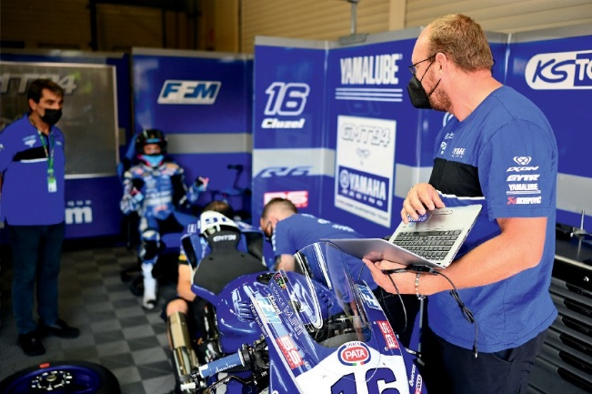

"The tester doesn't only focus on the voltage, it also examines the CCA (Cold Cranking Amps) to verify how the battery is truly operating, checks the alternator and the starter too.The indications appear on a large LCD screen in English, German, Spanish, French, Dutch or Italian".

It is delivered with a clamp set, pouch protection and a USB cable that is easy to connect to the computer

\ save or print out the diagnostics for clients.

**BS BATTERY**

**Paris, FRANCE**

**Tel: +(33) 1 83 62 45 60**

[**sales@bs-battery.com**](mailto:sales@bs-battery.com)[**www.bs-battery.com**](http://www.bs-battery.com/)