BS Battery - "the power you need" now available in USA

French battery specialist BS Battery has taken its business relationship with LeMans Corporation to another level.

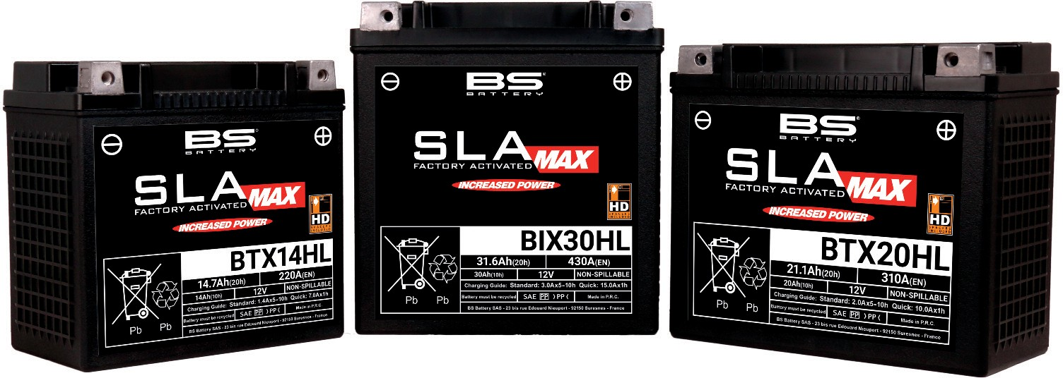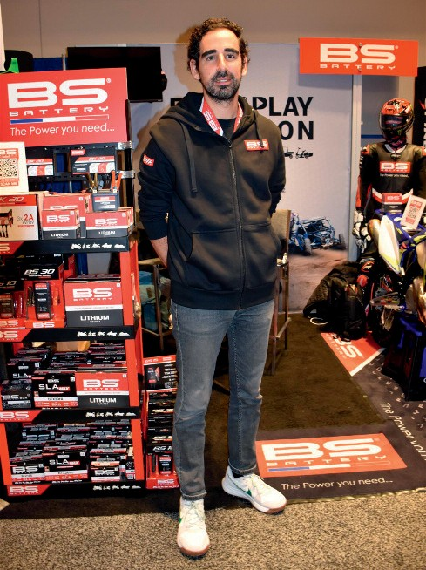

Having distributed through Parts Europe (Wasserliesch/Trier, Germany) for the past five years, the Paris based manufacturer has announced that it is now to be distributed by Drag Specialties and Parts Unlimited in the United States.

Present in both OEM and aftermarket sales, founder and General Manager Benjamin Sebban told IDN: "We offer an exhaustive range of battery solutions with all the technologies available - lithium batteries, AGM sealed lead acid batteries, AGM maintenance-free batteries for all powersports applications - motorcycle, V-twin, SSV,ATV, UTV, snowmobile and watercraft."

The company has even designed a dedicated line for big engines - called "SLA MAX" - with reinforced cases and grid framework to reduce vibrations and provide riding comfort, specific terminals to facilitate mounting without using spacer rings

**Founder and General Manager Benjamin Sebban told IDN: "We offer an exhaustive range of battery solutions with all the technologies available."**

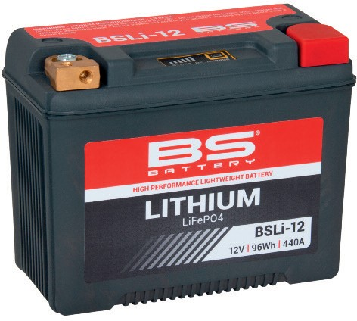

and an advanced construction design to increase the capacity and enhance starting power.

Focused on innovation, the manufacturer also offers lithium batteries with robust terminals, lighter weight (up to 70% lighter than lead acid batteries) and equipped with a voltage indicator to check the state of charge at any time.

"Thanks to our strong technical racing partnerships with leading racers and teams such as Fabio Quartararo (MotoGP World Champion), Yamaha GMT94 (World SuperBike), Kawasaki Bud Racing (MXGP), Sherco Racing (Enduro GP, Hard Trial) and others, BS Battery tests its products under extreme racing conditions to innovate more in lithium technology." [**www.bs-battery.com**](http://www.bs-battery.com/)