15th March 2023, Portimão
NEW |BS BATTERY x APRILIA RACING TEAMS UP FOR 2023 AND 2024 MOTOGP WORLD CHAMPIONSHIP!

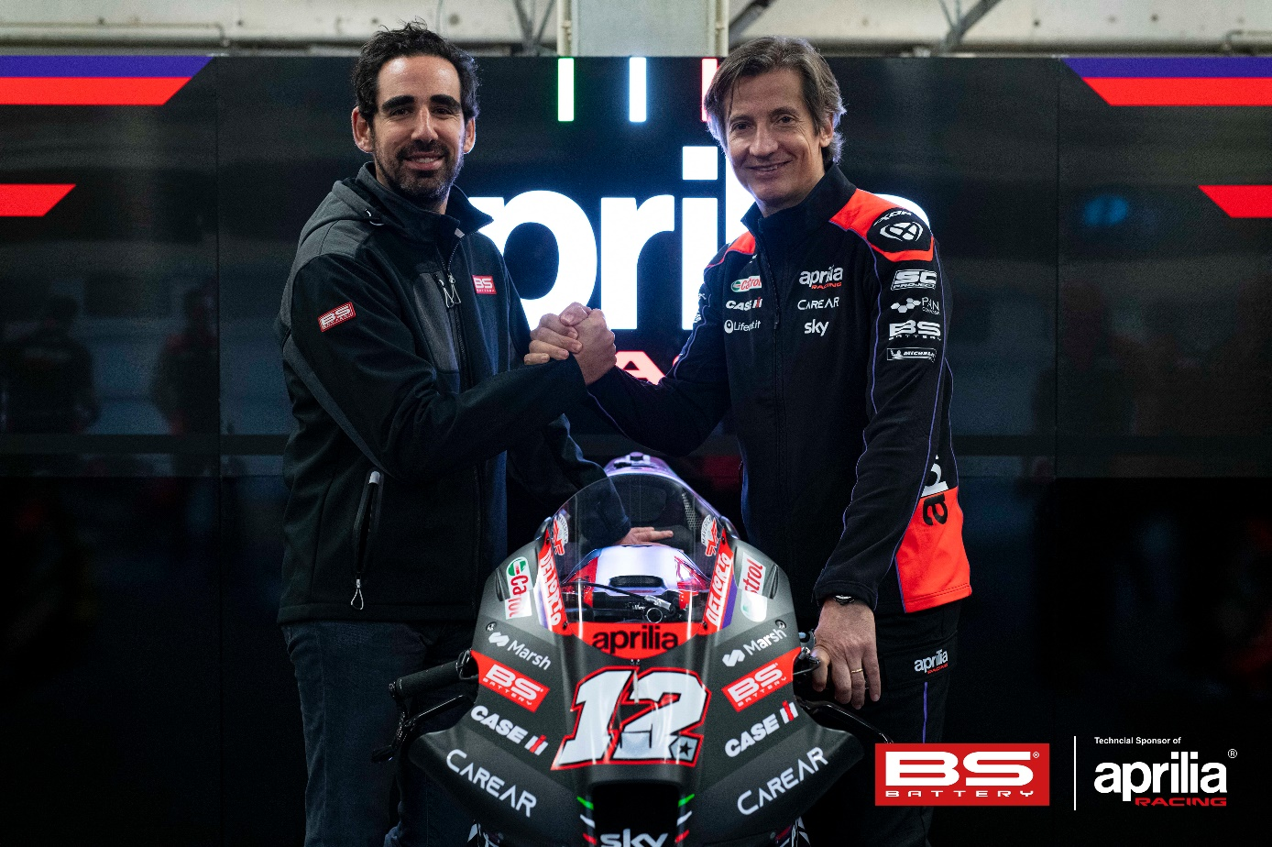

BS BATTERY and APRILIA never stop!
Today marks a new step in both brands history with this exciting union gunning for glory on the 2023 MOTOGP World Championship!

Becoming Official Sponsor of APRILIA RACING, BS BATTERY, French battery manufacturer, will support the RS-GP bikes and top riders on track represented by Aleix ESPARGARO and Maverick VIÑALES.
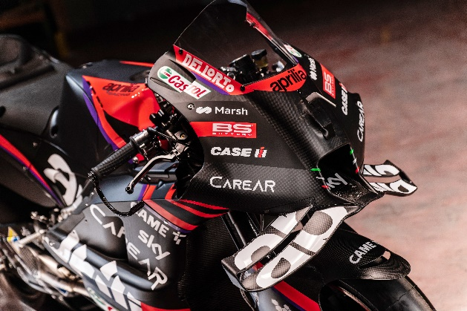
Benjamin SEBBAN, General Manager - BS BATTERY: ““We are proud to extend our relationship with Aprilia into the racing world. Brand and bikes are extremely powerful, we share the same DNA when it comes of innovation, passion and sharing! We both fight to keep our sport accessible to all as their club #bearacer claims! Standing by APRILIA RACING side is an honor, we are excited to start the season with the team and share exceptional moments with our clients too! I thank Massimo RIVOLA and all the APRILIA RACING management team for the warm welcome received. The BS BATTERY team stands by your side.”

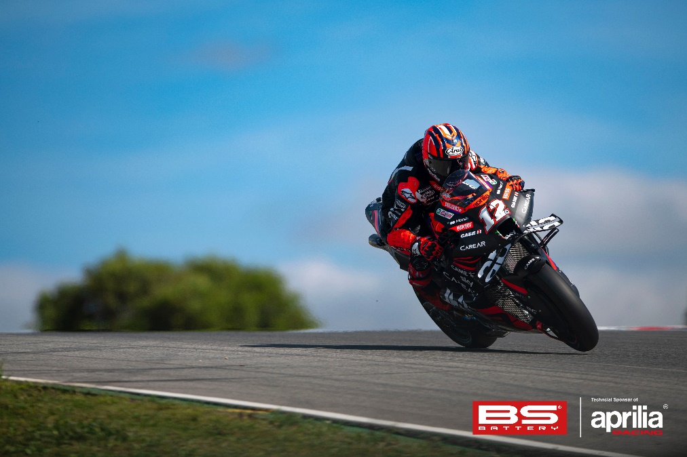
Massimo Rivola - Aprilia Racing CEO: “We are proud to have a partner like BS BATTERY at our side. A collaboration that stems from our enthusiasm and common values of innovation, technology and competition, and which we hope will prove its worth on circuits all over the world. Seeing important realities that decide to support our commitment loads us with pressure but, at the same time, fills us with pride.”

