**BS BATTERY EXTENDS LITHIUM RANGE FOR BMW MODELS !**

French battery specialist BS Battery is extending its Lithium range with new BSLi-13, designed with a special small 183 x 79 x 170 mm dimension for BMW models.

With cold cranking amps of 560A, this LiFeP04 battery is more powerful than its lead-acid equivalent (SLA Max range – 51913 – 275A), and 70% lighter than conventional batteries.

General Manager Benjamin Sebban told IDN that the BSLi-13 is “designed to fit BMW’s latest requirements. It is ready to use, easy to mount – with an inclination of up to 180 degrees – and crafted with robust terminals to enhance electrical performance and an LED indicator on the top to easily monitor the state of charge.”

“Our Lithium range has been developed for riders who look for higher and safer performance, faster acceleration, reduced weight and longer battery life. With a very low self-discharge, the BSLi-13 can start an engine after a very long period of storage, even in cold temperature conditions.”

Present in both OEM and aftermarket sales, Benjamin said that “we offer an exhaustive range of battery solutions with all the technologies for all powersports applications – motorcycle, V-twin, SSV, ATV, UTV, snowmobile and watercraft.

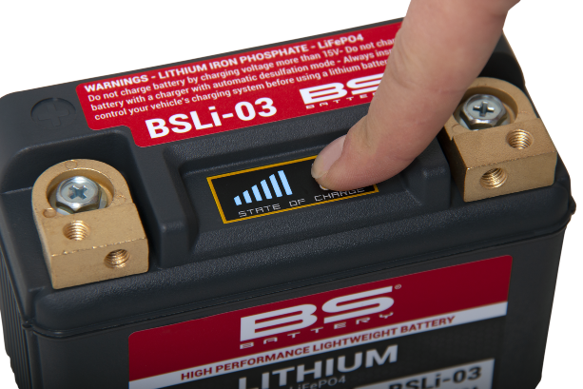“Thanks to our strong technical racing partnerships with leading racers and teams such as Fabio Quartararo (MotoGP World Champion), Yamaha GMT94 (World Superbike), Kawasaki Bud Racing (MXGP), Sherco Racing Factory (EnduroGP, Hard Enduro, TrialGP) and others, BS Battery tests its products under extreme racing conditions to innovate more in lithium technology."

**BS BATTERY SAS**

**Paris – FRANCE // Tel: +(33) 1 83 62 45 60**

[**sales@bs-battery.com**](mailto:sales@bs-battery.com)[**www.bs-battery.com**](http://www.bs-battery.com)