**BS BATTERY & FABIO QUARTARARO**

**TEAMS UP FOR TWO MORE YEARS!**

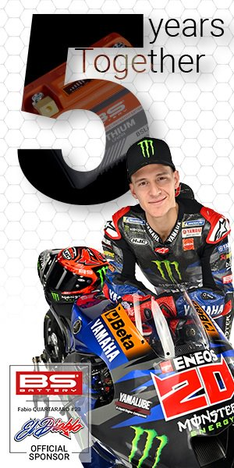BS BATTERY and Fabio QUARTARARO teams up for two more years of adventures!

This year marks the 5th anniversary of strong collaboration between the French battery manufacturer and the Moto GP rider!

Competing for the *FIM MotoGP World Championship* with *Monster Energy Yamaha MotoGP Team*, Fabio QUARTARARO seems unstoppable for this promising 2023 GP season!

Since 2019, BS BATTERY support the French pilot with technical advice and products (batteries, chargers, boosters, testers) on its training phases.

*“We’ve supported Fabio right from the start. When we met for the first time, I remember how we were dreaming of a MotoGP Podium… 5 years later combining 1 World Champion title and 1 Vice World Champion title, our dream comes true!*

*Fabio has faith and dedication, he doesn’t let obstacles stand in the way, we share the same vision! Consistency and passion drive us from the very beginning…Extending our partnership was just evidence!*

*We keep dreaming big together for this new season!”* highlight Benjamin Sebban, General Manager of BS Battery.

BS Battery and Fabio are ready to embrace exciting new challenges this year, starting with the Portuguese Grand Prix as first event of the 2023 FIM MotoGP™ World Championship, with the stunning Autodromo International do Algarve set to host the season opener from the 24th to the 26th of March 2023.



**BS BATTERY SAS**

**Paris, FRANCE**

**Tel: +(33) 1 83 62 45 60**

[**sales@bs-battery.com**](mailto:sales@bs-battery.com)

[**www.bs-battery.com**](http://www.bs-battery.com)