Big Power for Big Inches

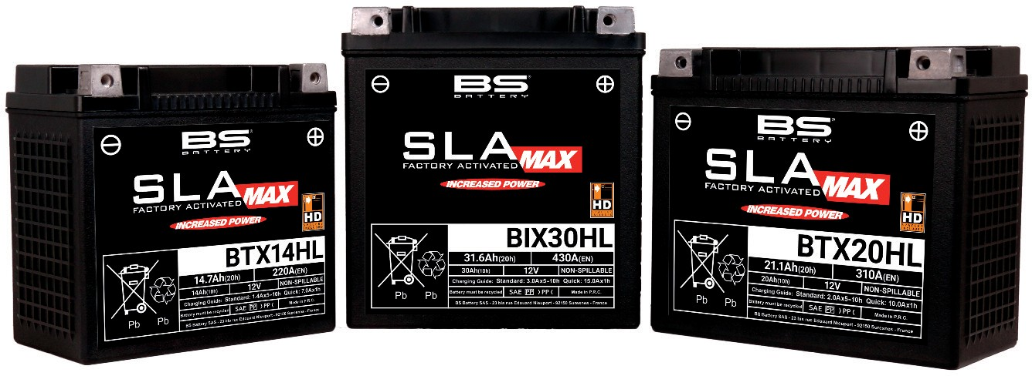

BS Battery offers an extensive range of battery solutions with all the technologies - lithium, AGM sealed lead-acid and AGM maintenance-free batteries, for all powersports industry applications - motorcycle, V-twin, SSV, ATV, UTV, snowmobile, watercraft.

At the top of the range, in terms of the kind of cranking amps needed for big inch V-twins, the company has designed a dedicated line for big engines such as those used in Harley-Davidson

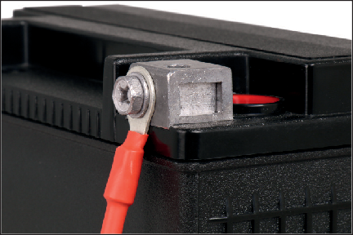

models called "SLA MAX" (BTX30HL, 20HL or 14HL).

Features include reinforced cases and grid framework to reduce vibrations and provide riding comfort, specific terminals to facilitate mounting without having to use spacer rings and an advanced construction design that increases capacity and enhances starting power.

Known as an OEM as well as aftermarket manufacturer, the focus at BS is on innovation. The company also offers lithium batteries for V-twin use with 12.8 voltage and up to 560 CCA with robust terminals, lighter weight (up to 70% less than lead- acid batteries) and equipped with an integral voltage indicator to check the state of charge at any time. Thanks to its strong technical racing partnerships such as with Fabio Quartararo (MotoGP World Champion), Yamaha GMT94 (WSBK), Kawasaki Bud Racing (MXGP), Sherco Racing (Enduro GP, Hard Trial) and many others, BS Battery develops and tests its products under extreme racing conditions to innovate more in lithium technology.

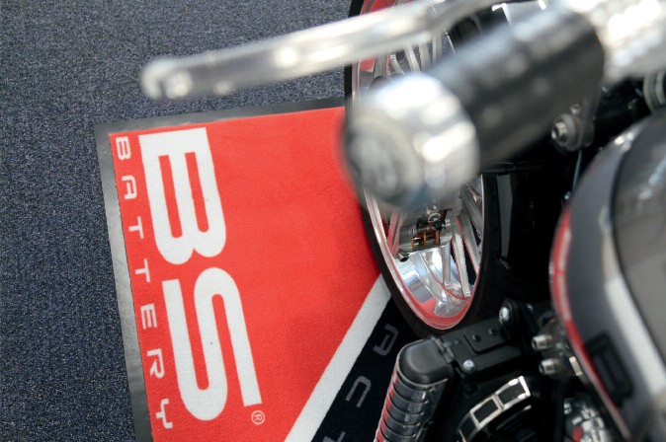

**BS BATTERY**

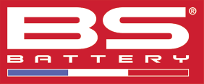**Paris, FRANCE**

**Tel: +(33) 1 83 62 45 60**

[**sales@bs-battery.com**](mailto:sales@bs-battery.com)[**www.bs-battery.com**](http://www.bs-battery.com/)