BK20 - Smart Charging Station

Mainly developed for warehouses, dealer and service workshops, the BK 20 from French battery and charger specialist BS Battery "is a real 3 in 1 solution which saves time for mechanics and provides a quality service to end users".

It is a smart bank battery charger and maintainer,

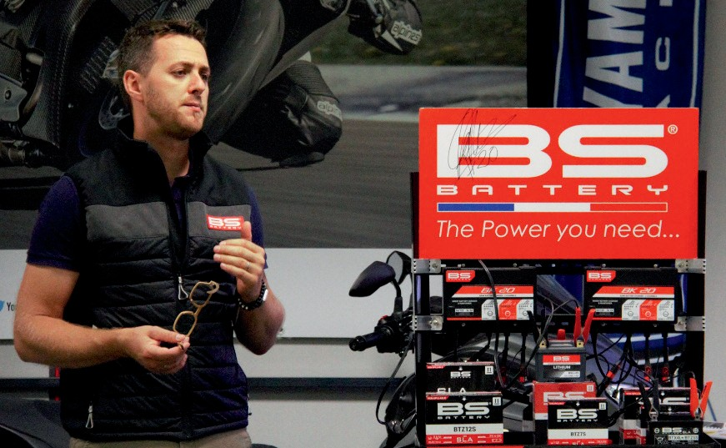

which offers 3 channels of charge - so it can charge and maintain 3 batteries with different voltages (6/12V) and technologies at once.

Rated at 2A per channel, this powerful automatic charger is suitable for lead acid and lithium batteries up to 40 Ah and even 80 Ah for maintenance.

Described as safe and easy to use, the BK 20 has 10 stages of charge "including a new 'Force Mode' to enhance the performance of all your powersports batteries.

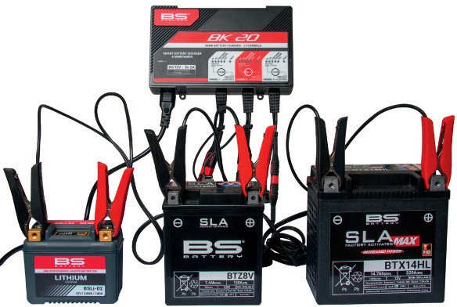

"Delivered with 3 BS clamps sets for a quick connection, this solution is a useful time saver for workshops and mechanics when they need to set up fresh batteries".

In addition, BS Battery has also designed a charging station including a product display with an assembly part to mount up x2 BK20 Smart Chargers. "The perfect solution for all the shops who want to exhibit their products and ensure a high-quality service by providing batteries fully charged to end-users," says founder and General Manager Benjamin Saban.

**BS BATTERY**

**Paris, FRANCE**

**Tel: +(33) 1 83 62 45 60**

[**sales@bs-battery.com**](mailto:sales@bs-battery.com)[**www.bs-battery.com**](http://www.bs-battery.com/)