**BS BATTERY EXPANDS ITS LITHIUM RANGE WITH THE NEW BSLi-14 MODEL**

Always concerned about innovation and performance, the French battery specialist BS Battery is extending its Lithium range with the new BSLi-14.

With special dimensions of 114x70x105mm and high CCA (210A), the brand-new BSLi-14 is designed to replace Honda’s original equipment on Africa Twin CRF 1000 and 1100 models.

Equipped with brass terminals to enhance electrical performance, this new model also includes a LED indicator on the top to easily monitor the state of charge.

With significant weight reduction (0,77kg), the BSLi-14 model also demonstrates high performance startup capabilities, even at low temperatures.

Ready to use, easy to mount with an inclination up to 180°, BS Battery Lithium range has been developed for riders who look for higher and safer performance, faster acceleration, reduced weight, and longer battery life.

With a very low self-discharge, the BSLi-14 can start an engine after a very long period of storage, even in cold temperature conditions.

Present in both OEM and aftermarket sales, founder and General Manager Benjamin Sebban told IDN: "We offer an exhaustive range of battery solutions with all the technologies for all powersports applications - motorcycle, V-twin, SSV,ATV, UTV, snowmobile and watercraft. Thanks to our strong technical racing partnerships with leading racers and teams such as Fabio Quartararo (MotoGP World Champion), Yamaha GMT94 (World Superbike), Kawasaki Bud Racing (MXGP), Sherco Racing (EnduroGP, Hard Enduro, TrialGP) and others, BS Battery tests its products under extreme racing conditions to innovate more in lithium technology."

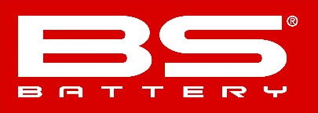

**BS BATTERY SAS**

**Paris – FRANCE // Tel: +(33) 1 83 62 45 60**

[**sales@bs-battery.com**](mailto:sales@bs-battery.com)[**www.bs-battery.com**](http://www.bs-battery.com)