NEW Power Box PB-02: your best friend this summer!
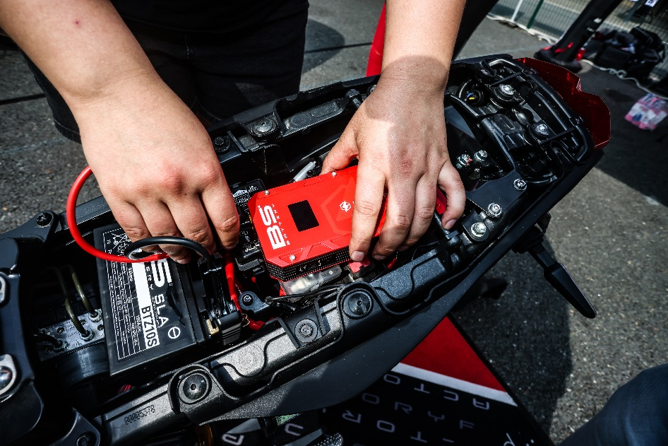

Freshly arrived, the POWER BOX PB-02, is the latest version of portable jump starter developed by BS BATTERY.

With a high jump-starting ability (1200 Amp) and a compact red design, the PB-02 is your best companion for summer!

Ultra safe including smart cables with spark-proof connection and reverse polarity protection, the PB-02 allows you to :

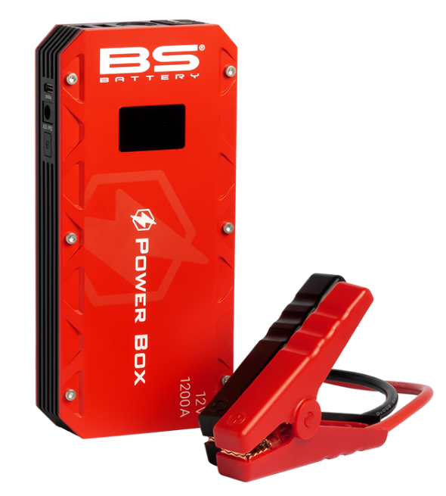
SAFELY JUMP START YOUR DEAD BATTERY on all type of vehicles (motorcycle, cars, watercrafts…)

CHARGE & RECHARGE your USB devices on the go

AVOID DARKNESS ON EMERGENCY CASES with 3 lights modes!

- SAFE BOOSTER
With improved starting performance, the POWER BOX PB-02 is now able to deliver 1200 Amp for jump starting 7.0L Gas and 6.0L diesel engines as well as all powersports vehicles equipped with a 12V Lead-Acid battery.

- POWER SUPPLY BANK
Thanks to its internal Lithium-ion battery and smart charging cables, the POWER BOX PB-02 can charge and recharge all your USB devices!

- FLASHLIGHT
The flashlight function provides 3 blinking modes with SOS, strobe and normal constant light.

BS BATTERY
www.bs-battery.com



