# BS Smart Chargers - "Connect and Forget"

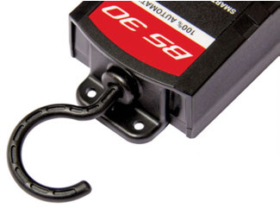

Riders are often faced with uncertainty about when to charge their motorcycle battery, for how long and what they should be monitoring, and that uncertainty is reinforced when they encounter slow cranking.

French manufacturer BS Battery says that its charger development program "paid attention to the small details that make the big differences for riders. Details such as an adaptable charging algorithm which allows them to keep the battery on charge as long as they want, without damage.

"Details such as a quick connection system - our chargers are delivered with a clamp set and fused ring terminals so riders can simply plug the charger to the battery without disconnecting it.

"With additional features such as an auto-detect for acid and lithium technology to eliminate doubt and internal overheat protection with spark free connection to eliminate reverse polarity and short circuit."

Distributed by Parts Unlimited and Drags Specialties

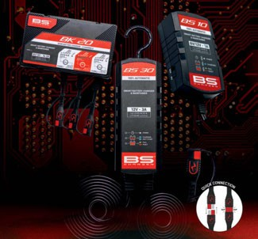

in the United States, and others including Parts Europe and Parts Canada, BS Battery provides 3 models matching all the latest certifications, applications and needs of the market.

The BS10 (6V & 12V - 1A) has a small, safe and road trip practical design; the ergonomic BS30 (12V - 3A) comes complete with a multi-axis hook; and the BK20 (6V & 12V - 2A) has been developed mainly for professionals - offering 3 channels of charge with different voltages and chemistries simultaneously, including a reconditioning function.

Owner and founder Benjamin Sebban says that "with more than 10 years' experience in the battery industry and, working closely with manufacturers to develop Original Equipment batteries (lead acid and, more recently, lithium), BS Battery has gathered a lot of information from manufacturers' engineering teams concerning their battery performance and specification requirements.

"That knowledge and experience can now be 'money in the bank' for BS Battery dealers with an upgraded BS charger line that is ideal for authorized and independent dealers and their customers."

**BS BATTERY, USA Office**

**Parrish, Florida, USA** [**sales@bs-battery.com**](mailto:sales@bs-battery.com)[**www.bs-battery.com**](http://www.bs-battery.com/)