Brough Superior - powered by
BS Battery

French battery specialist BS Battery has come a long way since the company was established in 2008 by industry veteran Alain Sebban. Operated daily by his son Benjamin Sebban, the company has travelled a long way in its 15 years.
Though best known to IDN readers as one of the fastest growing battery and charger brands - with six subsidiaries and sales in 80 countries - the company first introduced its charger line in 2011, with its 'SLA' batteries launched in 2014, followed by the 'SLA' Max a year later and its lithium battery program in 2019.
A new Gen 2.0 range of smart chargers came to market in 2021, and throughout the past decade, BS Battery has built its road and off-road race credentials - with riders such as Johann Zarco, Fabio Quartararo, Aleix Espargaro and Maverick Vinales.
However, while it isn't a closely held secret, BS Battery's profile as an OEM battery manufacturer gets less attention, and it is the demands of meeting or exceeding OEM specifications that has driven the manufacturing quality, power and features of its aftermarket battery and charger programs.
Certified to ISO 9001, ISO 14001 and ISO/TS 16949, BS Battery "went through very long quality validation processes and audits to obtain manufacturer approvals," says Benjamin, and supplies major manufacturers worldwide, including the Brough Superior reincarnation seen here, headed up in France by Thierry Henriette.
"We have been partnered with Brough Superior for a couple of years now," Benjamin explained. "We started together with our lead acid battery, and we recently upgrade their bikes with our lithium solutions - our newest lithium range design, distinguished by the red top.
"Renowned as the 'Rolls-Royce of

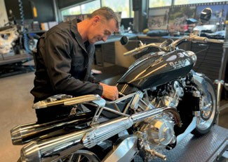

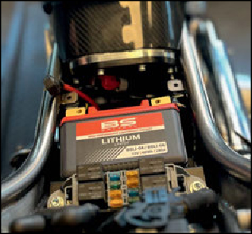
motorcycles', we are proud to be Original Equipment Manufacturer for Brough Superior and Aston Martin bikes, and happy that the new iteration of the brand is built right here in France. "Both our companies share the same vision of leading through passion and excellence, and now both companies are bringing their expertise together to perpetuate the brand’s legendary heritage. Brough Superior is revolutionizing the luxury motorcycle industry by combining timeless design with its exclusive patented engine. "The fact that Brough Superior chose our batteries for such an up-scale undertaking shows how well regarded our technology and manufacturing quality is. Over 100 years after George Brough founded the original company, respected motorcycle designer Thierry Henriette is at the helm of a passionate team that carefully handcrafts each bespoke motorcycle that leaves its workshop.
"Led by the same passion for adventure, technology and excellence, the connection between Brough Superior and BS Battery was unmistakable. In alignment with its DNA of quality and excellence, every masterpiece that comes out of the Brough Superior workshops is powered by the BSLi-04/06 Lithium LifeP04 battery.

"Lighter weight, high cold cranking performance, robust brass terminals, extensive cycle life, low self-discharge and strong heat resistance - the BSLi- 04/06 was indisputably the technical choice to meet the requirements of its high-performance engine. In addition, we also provide our BS10 smart charger and maintainer, which comes with each Brough Superior and Aston Martin bike."

BS BATTERY
Paris, FRANCE
Tel: +(33) 1 83 62 45 60
sales@bs-battery.com www.bs-battery.com

