**SMART CHARGERS: Fresh look unveiled at EICMA!**

8 November 2023

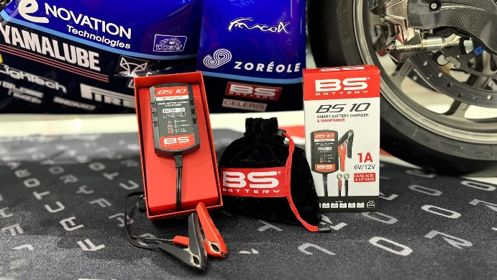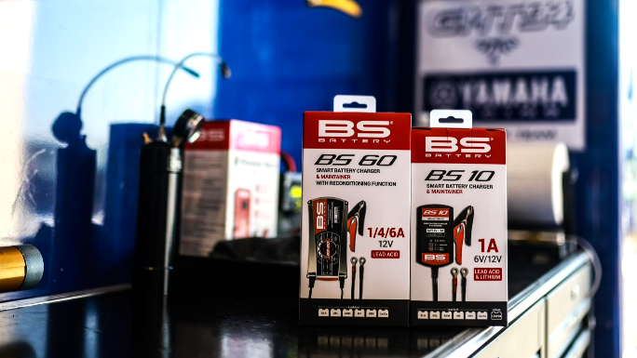

As an integral part of our customer-oriented strategy, we are thrilled to introduce a new look for Smart Chargers & Maintainers range, setting a new standard for user convenience and product protection.

The newly revealed packaging designs at EICMA 2023 are the result of meticulous attention to detail and creative development. Crafted with a keen eye on aesthetics and functionality, these designs aim to enhance the overall user experience, making each interaction with our products more memorable.

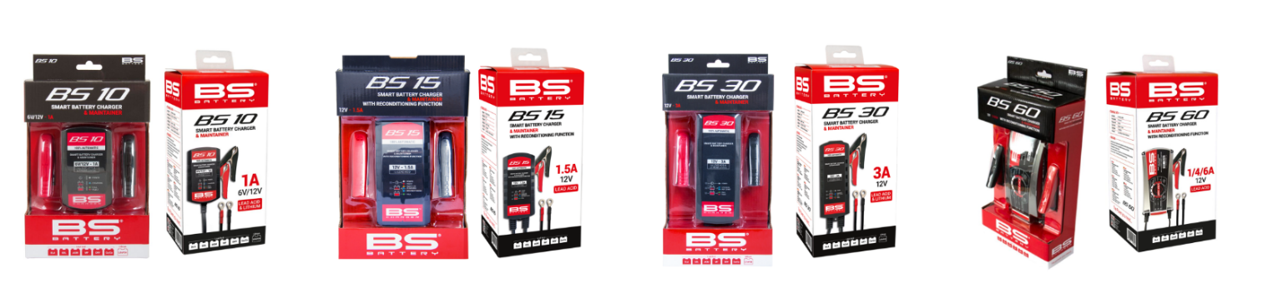

Each packaging has been carefully crafted to be user-friendly, with a stronger box and easy-to-understand graphics. Riders can quickly access their chargers and bring it everywhere thanks to a new velvet bag included making the unboxing experience seamless.

With visually appealing designs and branding elements, these brand-new packaging ensures that BS BATTERY chargers reach customers in perfect condition, protecting them from potential damage during shipping and storage.

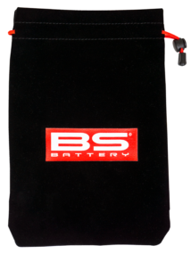

They feature a hook on the top of the box and a shrinked color box. All are also delivered with a new velvet travel bag.

