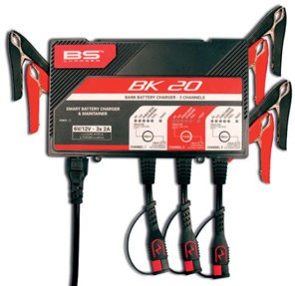

Charging Smart, Charging Safe

For factory-activated batteries, especially lithiums that require a specific charger, one thing is for sure: charging and maintenance are crucial to the battery lifespan - something that is an especially important consideration for the professional workshop environment where the potential for damage from misuse of acid chargers on lithium batteries is so much more serious.

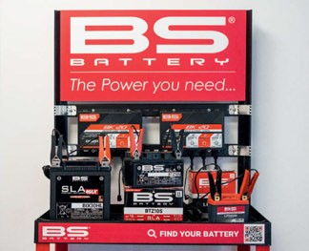

French battery and charger specialist BS Battery has developed a convenient and easy tool specifically to help dealers make the right charging decision - the BK20. "A really versatile solution," says BS Chargers Florida Office Manager Frank Pitman, "this genuine 3 in 1 solution saves time for mechanics and provides a quality service to end users.

"An intelligent bank charger and maintainer that offers three charge channels, it can simultaneously charge and maintain three batteries with different

voltages (6/12V) and technologies.

"Rated at 2A per channel, this powerful automatic charger is suitable for charging and maintaining all battery sizes - lead-acid and lithium up to 40 Ah, and even up to 80 Ah for in maintenance mode."

High-performance features include automatic detection technology to enable warehouses, dealers or service workshops to eliminate doubt with the back-up security of internal overheat protection and spark-free connection to eliminate reverse polarity and short circuit.

"The ten charge stages include a new 'Force Mode' to enhance the performance of all powersports batteries. Delivered with three BS clamp sets for a quick connection and hang anywhere hooks, this solution is a useful time-saver for workshops and mechanics

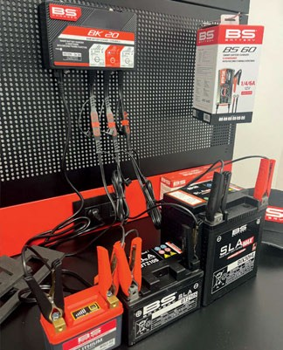

when they need to set up fresh batteries."

Always known for "the tiny details that make the big differences for riders," the French manufacturer has also designed a charging station that includes a product display with an assembly point to mount up two BK20 smart chargers.

"The perfect solution for all the shops who want to exhibit their products, and ensure a high-quality service, by providing batteries fully charged to end users," says founder and General Manager Benjamin Sebban.

BS Battery smart chargers match all the latest U.S. certifications. They are delivered with clamps set and fused ring terminal set. Distributed throughout the

U.S. by Drag Specialties/Parts Unlimited and by distributors in Europe, including Parts Europe.

# BS BATTERY USA

**Largo, Florida USA** [**sales@bs-battery.com**](mailto:sales@bs-battery.com)[**www.bs-battery.com**](http://www.bs-battery.com/)

[**www.AMDmag.com**](http://www.AMDmag.com/)