**NEW BGZ SERIES – MAXIMAL PERFORMANCE FOR BIG ENGINES**

Unveiled at EICMA, BS BATTERY has expanded its SLA MAX range with 5 new models called “BGZ Series” to meet the robust performance needs and enduring reliability expected from high-powered touring motorcycles.

These latest AGM generation batteries have been crafted with built-in copper nuts terminal to enhance the conductivity up to 50% than standard terminal and improved max torque strength up to 13N.m. With robust taller plates designed to improve starting power, these 12V batteries offer a maximal performance to big-engine vehicles with high requirements and equipped with lot of electronic equipment’s.

Ready to use, 100% maintenance free and non-spillable, BS BATTERY has unveiled the most powerful models in its Sealed Lead Acid lineup. With a starting power, cycle life and capacity up to 20% higher than the SLA (Sealed Lead Acid) range, the new BGZ series is a premium battery choice for select V-Twin, Metric, ATV and UTV applications!

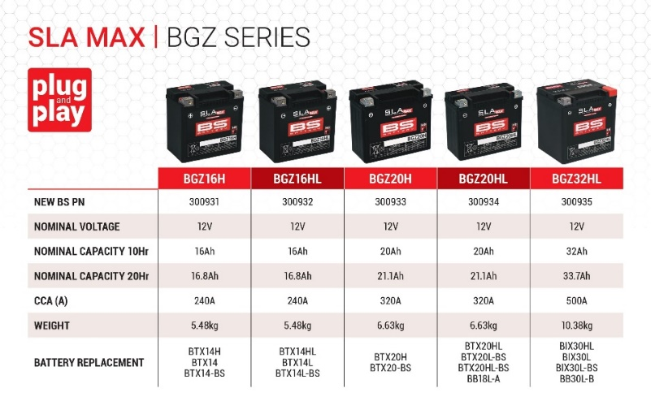Discover all BS BATTERY models here:

* [**BGZ 16H**](https://bs-battery.com/product/bgz16h/)
* [**BGZ 16HL**](https://bs-battery.com/product/bgz16hl-sla-max/)
* [**BGZ 20H**](https://bs-battery.com/product/bgz20h-sla-max/)
* [**BGZ 20HL**](https://bs-battery.com/product/bgz20hl-sla-max/)
* [**BGZ 32HL**](https://bs-battery.com/product/bgz32hl-sla-max/)