**BGZ SERIES – The latest SLA MAX generation**

**BGZ SERIES: MAXIMAL PERFORMANCE FOR BIG ENGINES**

With 5 models, this latest AGM generation batteries have been crafted to meet the robust performance needs and enduring reliability expected from high-powered touring motorcycles.

Designed with built-in copper nuts terminal to enhance the conductivity, with taller plates to increase the starting power and extend cycle life, these 12V batteries offer a maximal performance to big-engine vehicles with high requirements and equipped with lot of electronic equipment’s.

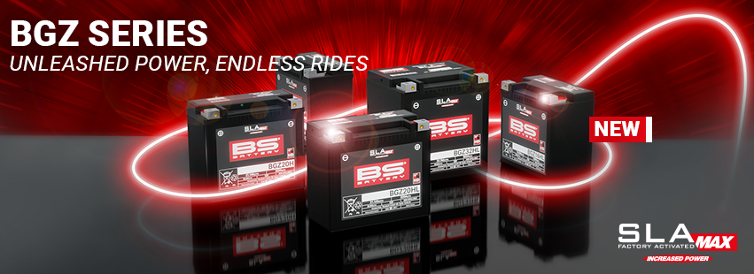

Ready to use, 100% maintenance free and non-spillable, with a capacity up to 10% higher than BTX SLA MAX, the new BGZ series is a premium battery choice for select V-Twin, Metric, ATV and UTV applications!

Discover all our models here:

* [**BGZ 16H**](https://bs-battery.com/product/bgz16h/)
* [**BGZ 16HL**](https://bs-battery.com/product/bgz16hl-sla-max/)
* [**BGZ 20H**](https://bs-battery.com/product/bgz20h-sla-max/)
* [**BGZ 20HL**](https://bs-battery.com/product/bgz20hl-sla-max/)
* [**BGZ 32HL**](https://bs-battery.com/product/bgz32hl-sla-max/)

