**LITHIUM MAX – A NEW RANGE FOR MAXIMUM PERFORMANCE TAILORED TO THE LATEST STANDARDS.**

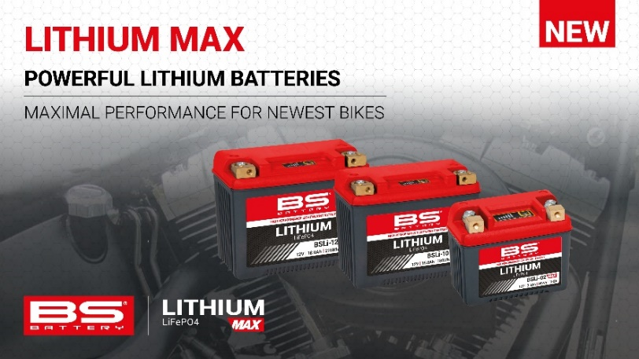

Unveiled at EICMA, BS BATTERY has extended its Lithium solutions with the introduction of a new range: [**LITHIUM MAX**](https://bs-battery.com/battery-range-bs-battery/lithium-max/).

This latest lithium generation has been crafted to meet the demanding standards of modern vehicles such as off-road bikes, high-performance V-Twin, ATV / UTV / SSV…

The growing reliance on electrical components requires higher capacity solutions - to address this need, BS Battery has developed the new **LITHIUM MAX** range, which meets the latest standards required for present-day motorcycles (OEM) fitting.

The range includes 3 models feature larger pouch cells for enhanced CCA and capacity:

* [**BSLi-02 MAX**](https://bs-battery.com/product/bsli-02-max/)

Mainly developed for new and latest off-road bikes, with a Cold Cranking Amps (CCA) of 180A and capacity of 3 Ah - while maintaining its famous lightness (up to 70% lighter than Lead Acid batteries).

* [**BSLi-10 MAX**](https://bs-battery.com/product/bsli-10-max/)

Designed to meet the exacting specifications of modern V-TWIN, this reliable model features 750A(CCA) and a capacity up to 15Ah to ensure smooth starts and consistent performance in all conditions.

* [**BSLi-12 MAX**](https://bs-battery.com/product/bsli-12-max/)

With a CCA of 900A, this model provides the highest cranking power available in the range, ideal for larger vehicles like ATV/UTV/SSV. With a capacity of 18Ah, the robust pure brass terminals and durable materials make them resistant to vibration and shock.

Well-known among these little sisters (**BSLi-02, BSLi-10, BSLi-12**), we also find the state of charge indicator which allows to monitor the state of charge of the battery thanks to LED lights.

Ready to use, light, efficient, and resistant, BS BATTERY has unveiled the most powerful models in its Lithium solutions lineup. With a superior capacity, maximum starting power, and enhanced conductivity, the new **LITHIUM MAX** batteries are a premium choice for the newest fitting requirement in all applications.​

