Technical Partnership: Powering Racing World

For 6 years, BS BATTERY has pursued its technical partnership with the YAMAHA GMT94 Racing Team, which embarks on the World Superbike Championship for a new season!

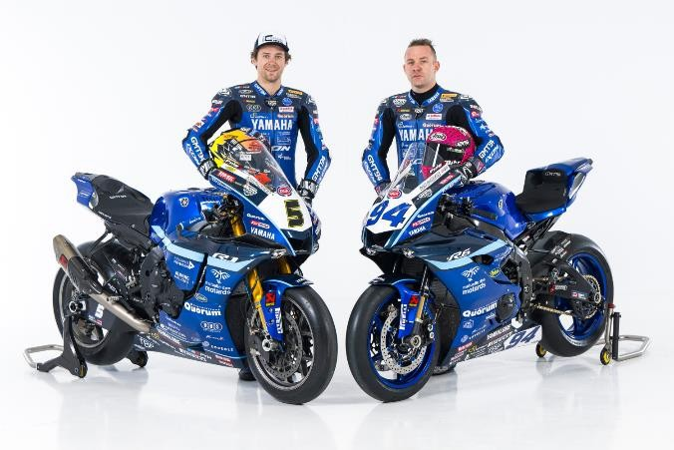

The French independent team has become an absolute reference in the motorcycle world. Three-time FIM Endurance World Champions, YAMAHA GMT94 succeeded in building a significant reputation thanks to several victories and a deep racing passion.

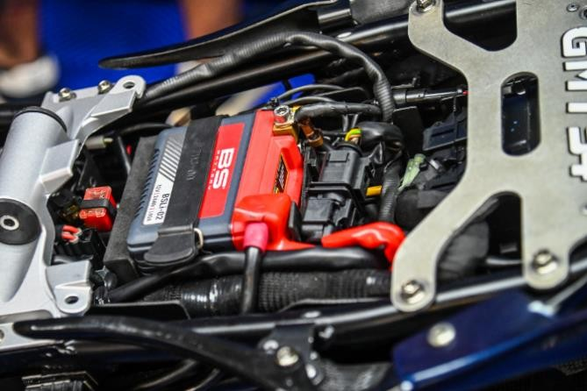

YAMAHA GMT94 will attend FIM WorldSBK races with a new German rider, Philipp ÖTTL (#5) aiming to take podiums on his latest-spec Yamaha R1 powered by a unique lithium battery developed in collaboration with the French battery manufacturer BS BATTERY. For the 2024 FIM World Supersport Championship season, the two-time World Champion Lucas Mahias will ride his Yamaha YZF-R6, powered by BS BATTERY **BSLi-02 lithium battery.**

As a core element of its DNA, BS BATTERY has been invested heavily in all racing activities since 2017, expanding its **technical sponsorship and R&D programs in road race**, **enduro, and rally racing**. A

partnership with Yamaha GMT94 acts as a real added value for technical development and performance improvement – "*We know the demands that the racing environment places on batteries and now have the most advanced real- world solutions to make our lithium battery the most robust and reliable.*" says General Manager Benjamin Sebban.

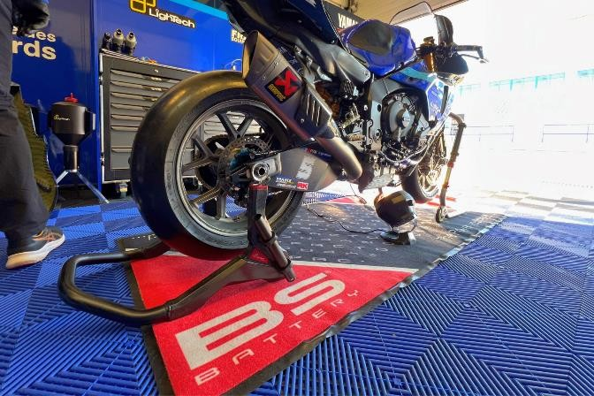

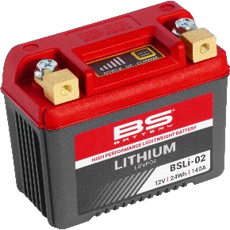*"Our lithium batteries has a unique design with robust brass terminals and a composite fiber material case that can resist up to -230 degrees C. These batteries are lightweight with an extensive life cycle covering most of the existing circulating park fitments with 14 models in the range."* explains Romain Menduni, Product Manager of BS BATTERY.

Thanks to such solid technical racing partnerships with leading racers and teams, BS BATTERY will continue to test its products under extreme racing conditions and increasingly innovate in lithium technology.

**BS BATTERY SAS**

**Paris, FRANCE**

+(33) 1 83 62 45 60

[sales@bs-battery.com](mailto:sales@bs-battery.com)

[www.bs-battery.com](http://www.bs-battery.com/)

