**NEW - PA-01 EYELET CONNECTOR JAR: THE COUNTER SOLUTION!**

As an integral part of our customer-oriented strategy, we are pleased to introduce our new **PA-01 eyelet terminal connector (M6) JAR:** a game-changer for the shop's counters!

While the product itself remains the same [accessory](https://bs-battery.com/product/pa-01/), we are expanding our offer with a new packaging solution that combines 20 cables into one jar. This new box has been designed to streamline the selling experience at the shop’s counter or simplify the process for mechanics in the workshop.

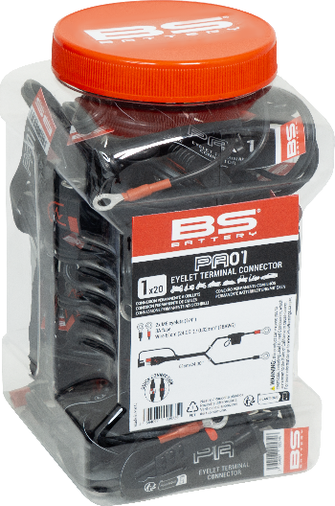

The jar features a **box of 20 connectors**, allowing quick access and convenient storage anywhere.

As the go-to solution for shops / workshops seeking ease of use and reliability, this design puts the focus on convenience and practicality!

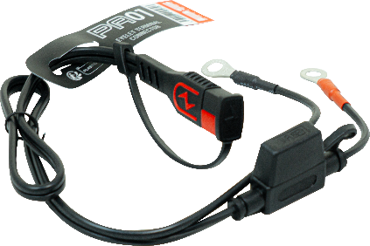

##### The [connector PA-01](https://bs-battery.com/product/pa-01/) also remains available individually with a new per-item look: a color box instead of blister pack.

##### Whether your battery is hidden, difficult to reach, or traditional clamps cannot be used, the PA-01 and its fused ring terminal lead set are the ideal solution: just connect the eyelet terminals to the battery and charge normally.

**Key features of the PA-01 include:**

* Fused Ring Terminal Leadset: Ideal solution if your battery is difficult to access.
* For all vehicles equipped with Lead Acid or Lithium batteries
* Easy to connect:
  + Connect red eyelet on positive battery terminal (+)
  + Connect black eyelet on negative battery terminal (-)
  + Connect this accessory to the quick connection of your BS Battery Charger
* 2 x M6 eyelets (1/4")

3A Fuse

Wire 61 cm (24.00")/ 0.82mm² (18AWG)

* Safe: connection spark free, reverse polarity, short circuit and internal overheat protection