**Fabio Quartararo and BS BATTERY: Powering Towards Victory in the 2024 MotoGP Season!**

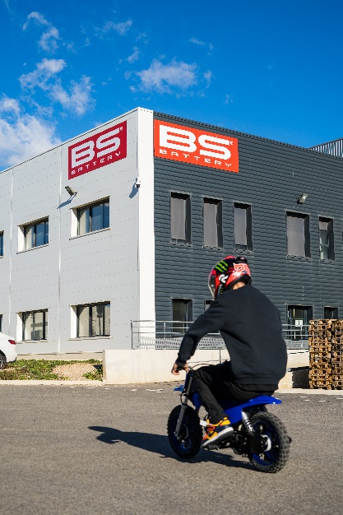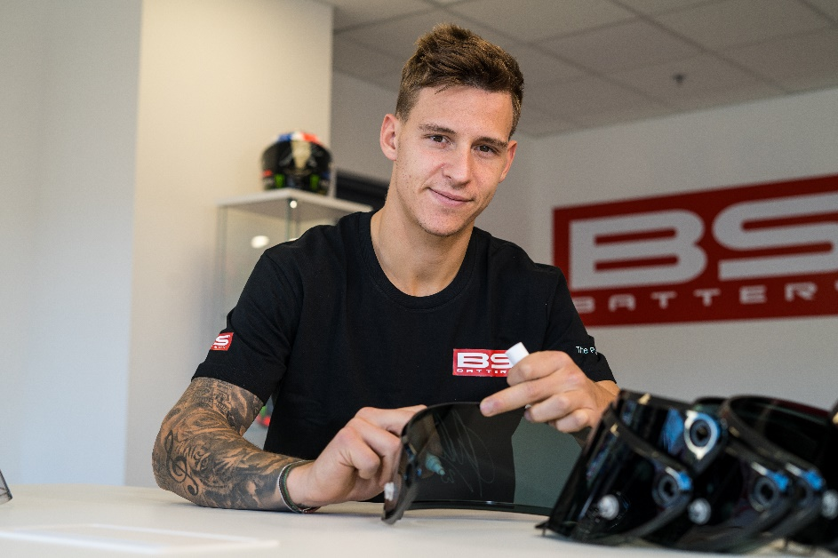Fabio Quartararo has officially launched its 2024 MotoGP season with the three-day official Sepang test and concluded the preseason testing program in Qatar. It’s now set to be a landmark year as MotoGP™ celebrates the 75th anniversary of motorcycle Grand Prix racing in 2024.

For a sixth consecutive season, BS BATTERY and Fabio are teaming up to take a big step in the right direction after a rough 2023. Since the world’s most exciting sport was born in 1949, 126 riders have become World Champions – many more than once. Next season, Fabio is determined to come back, fighting to make 2024 his year and join the list a second time.

The upcoming MotoGP season is shaping up to be a big one, currently projected to count 21 GP rounds and 42 races, as the MotoGP race weekend format will once more consist of a MotoGP Sprint on Saturday and a MotoGP Race on Sunday. With 11 races before the summer break and 11 after, it will be a long and intense season, where both performance and endurance will count to achieve championship success. Since 2019, BS BATTERY has supported the French pilot with technical advice and products (batteries, chargers, boosters, testers) in its training phases.

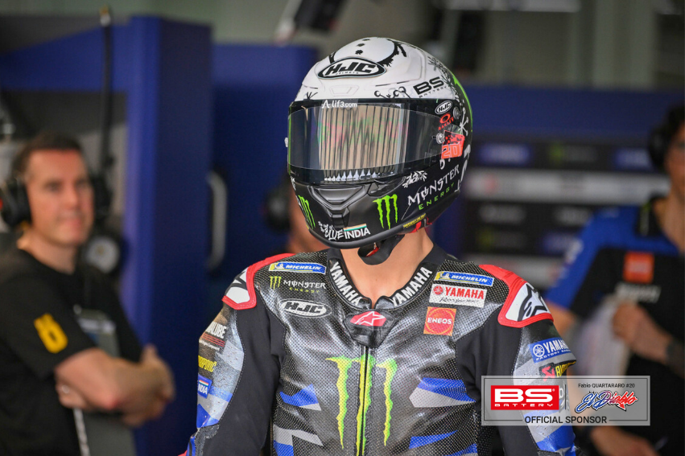The tone is set: “As always, we will put everything we have into every day, every session, every run, and every lap. I want to fight at the front, and I want to greet my fans from the top step of the podium again!” — Fabio Quartararo.

**Let's join forces to tackle this together. The collaboration on the track represents our shared vision of pushing boundaries and achieving greatness!**

Best of luck, Fabio. May the season be filled with energy, power, and success.

