**KAWASAKI BUD RACING & BS BATTERY: A strong alliance which persists into 2024 Season!**

BS Battery and Kawasaki Bud Racing team proudly announce the continuation of their partnership for the 2024 season. This collaboration has always been a mutual success, and BS Battery is extremely proud to stand alongside this French team as they embark on their season across various championships!

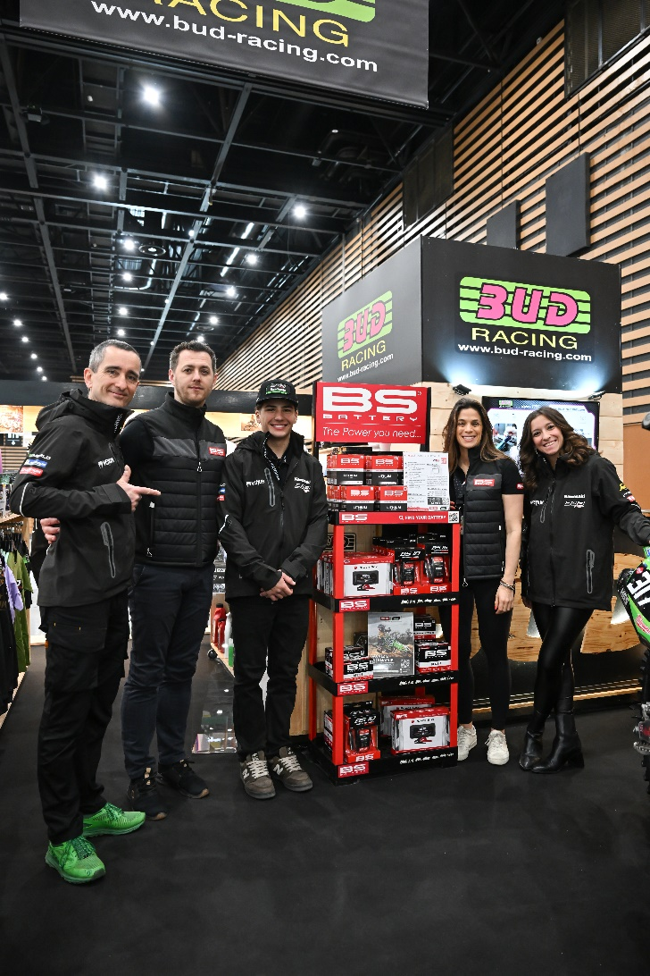

***\*To celebrate the official kick-off of the season, BS Battery joined the Kawasaki Bud Racing team at the Salon du 2 Roues in Lyon, France, early March.***

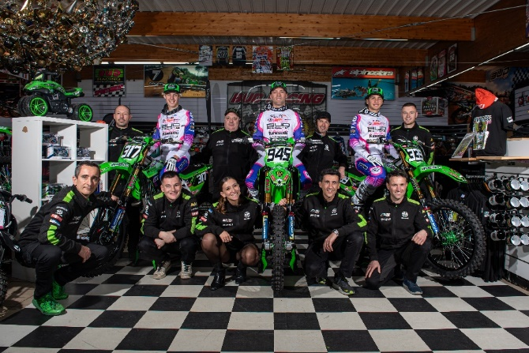

This year Kawasaki Bud Racing will compete in 4 championships: WSX World Supercross Championship, French Supercross & Motocross Championships and EMX250 European Motocross Championship. This diverse range of competitions showcases the team's versatility and skill on the track.

***\*2024 Kawasaki Bud Racing Team***

Off-road races are always demanding: the track becomes trickier every minute, and the bikes can be quickly damaged. The unpredictable grounds allow BS BATTERY to test the durability of our products in extreme conditions.

"The off-road field has always had this relish at the heart of the racing DNA and the keystone of our product development.” confirmed Eva CASTELAIN, Global Marketing Manager at BS BATTERY.

As a key sponsor of Kawasaki Bud Racing Team, BS Battery is committed to providing technical support and expertise to ensure peak performance on the track, such as **BSLi-02 lithium battery** which power all Kawasaki's motocross models. Approved and validated by the team, this battery delivers increased power and lightness (70% than Lead Acid batteries) optimizing the power of KX450 and KX250 models on track.

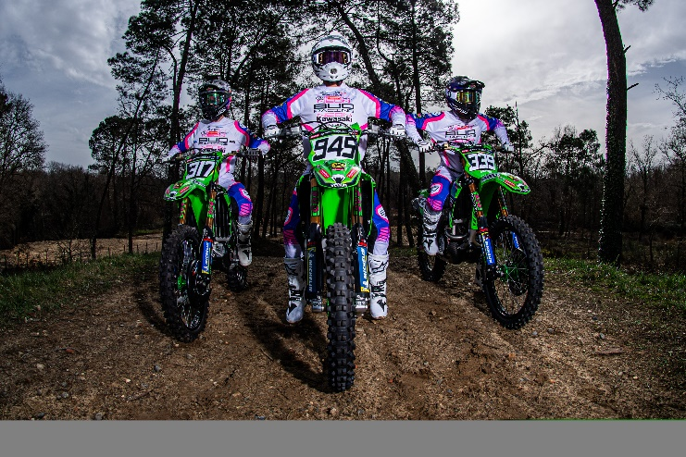

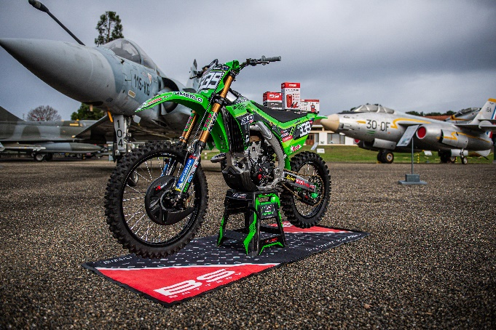

This year, BUD RACING welcomes:

* **Mathis Valin** young French talent. At just 17 years old, the newly crowned 125cc world champion has shown immense promise and has now decided to join forces with the Bud Racing Kawasaki team to move up to the next category, the EMX250 European Championship.
* **Benjamin Garib**, the 19-year-old Chilean rider has signed for a 2nd year with the team.

Under the guidance of former Supermotard world champion Thierry Van Den Bosch, both Mathis and Benjamin will receive expert training and support as they strive for success on the track.

* 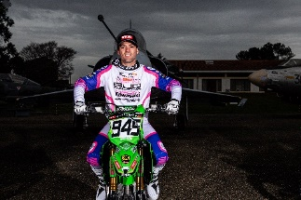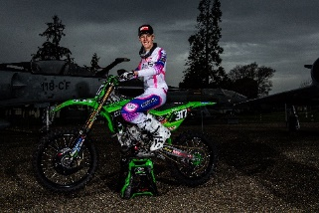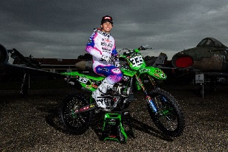Currently competing in the American Supercross Championship **Anthony Bourdon’s** experience and skills will be invaluable for 2024 as he represents the team in various international events!

Full power on 2024 season for the green team!