**Aprilia Racing and BS BATTERY: Official 2024 kick off!**

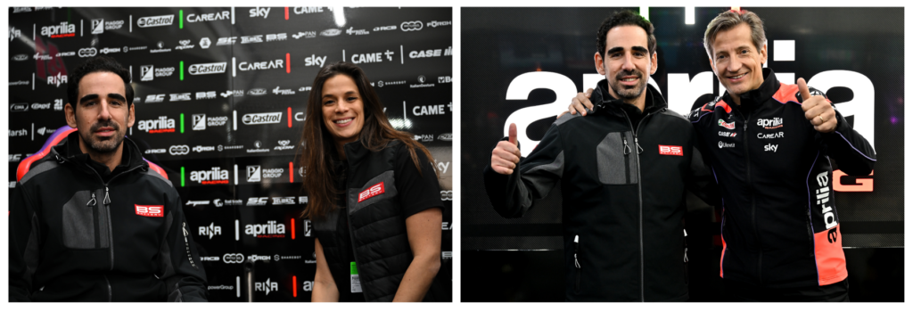Following the unveiling of the Aprilia RS-GP24 in its official version days ago, the Aprilia Racing team and BS Battery are more than up for battle at the top levels of MotoGP™ as partners for a second season!

From road as an Official Equipment Manufacturer for all Aprilia bikes since 2020 to track, BS Battery proudly stands as an Official Sponsor of the Aprilia Racing Factory team, extending unwavering support to the four RS-GP bikes and three exceptional riders—Aleix ESPARGARO, Maverick VINALES, and tester Lorenzo SAVADORI—on the fiercely competitive track.

With Aleix and Maverick in the top ten in MotoGP Qatar last weekend, the team bespeaks an unshakeable spirit and determination to fight until the very last lap in pursuit of victory!

After two seasons of constant growth, 2024 represents the year of confirmation for Aprilia. The technical advancements achieved have propelled both bike and team to unprecedented heights, all while staying true to Aprilia’s distinctive DNA. This evolution, characterized by innovative choices that lead the way for others, finds its most extreme manifestation in the latest iteration of the RS-GP.

Every aspect of the Italian masterpiece has undergone meticulous redesign and enhancement, from aerodynamics to engine, chassis to electronics, and strategies, leaving no stone unturned while retaining a clear lineage with the highly competitive 2023 foundation.

***[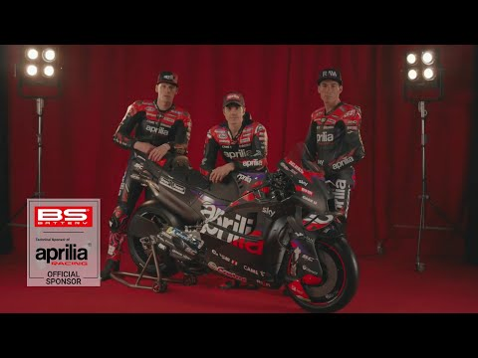](https://www.youtube.com/embed/HsscSnwNbBA?feature=oembed)***

***[Youtube video : BS BATTERY x APRILIA RACING I MotoGP™ I NEW RS-GP 24]***

**BS Battery takes immense pride in fueling this boundless ambition, which now burns brighter than ever before!**

