BS Battery Riders at 24 Hours of Le Mans 2024 : Recap of the 47th Edition
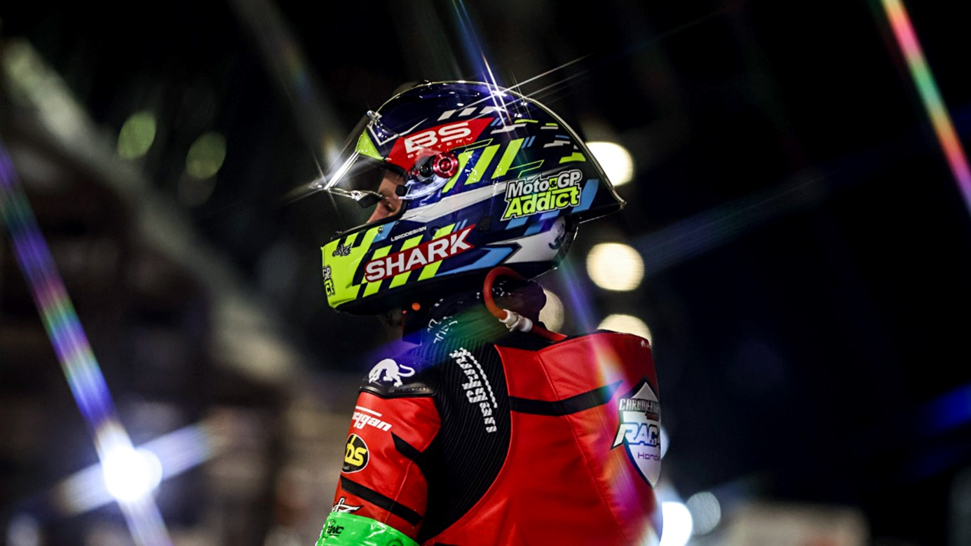

The 24 Hours of Le Mans 2024 ended on Sunday at 3 p.m. on the Bugatti circuit with a stunning performance of our riders, powered by BS Battery. Despite facing daunting weather conditions and fierce competition, our riders demonstrated determination in this prestigious endurance event.

Out of the 48 starting teams, the race saw 19 unfortunate withdrawals, making this edition one of the toughest in recent years!

We are delighted to share the outstanding achievements of our racing partners :

- Chromeburner-RAC 41-HONDA #41 – Martin Renaudin: PODIUM 2nd place in the Superstock category/ 9th place overall
- KAWASAKI WEBIKE TRICKSTAR #11: 4th place overall
- TEAM BOLLIGER SWITZERLAND #8: 7th place overall.
- JUNIOR TEAM LE MANS SUD SUZUKI #72: 12th place overall / 4th place in the Superstock category.
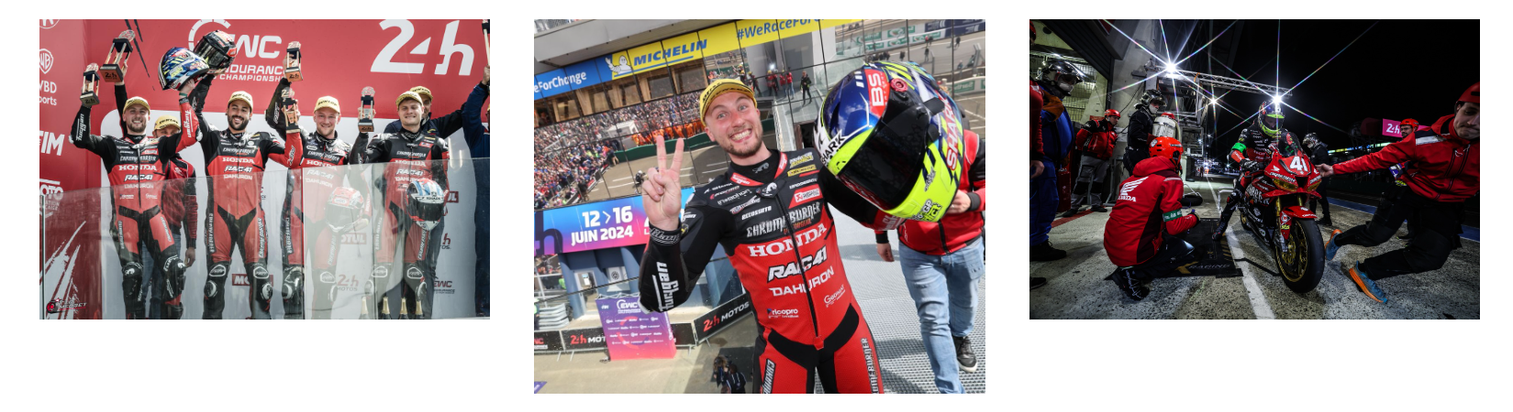
- TCP RACING #83 – Marcus Delestre : 14th place overall / 5th place in the Superstock category.
BS Battery proud to power these exceptional riders with our lithium batteries in the most demanding racing conditions,
Once again, congratulations to all our riders on their outstanding performance, and we look forward to continued success!

