**Breathtaking Americas Grand Prix for BS Battery!**

Austin, TX, April 14, 2024 -

BS Battery marked an outstanding presence at the Circuit of The Americas (COTA) this weekend during the Americas Grand Prix alongside its esteemed partner Le Mans Corporation!

Our USA team connected with fans and industry insiders at the Parts Unlimited and Drag Specialties hospitality at turn 19, exclusively for their dealers. Amidst the sound of roaring GP bike engines, BS Battery displayed its products, talked about motorcycles and batteries, and enjoyed the thrilling race atmosphere.

A highlight of the weekend was Fabio's visit to the hospitality area, where he engaged in insightful exchanges with dealers and teams, topping a fan-favorite signing session!

Taking their commitment to the next level, BS Battery offered select dealers and sales representatives an exclusive experience behind the curtain of racing glory, granting them access to the inner place of the Aprilia Racing Team. They embarked on stunning garage tours, in the heart of the action with the team and riders.

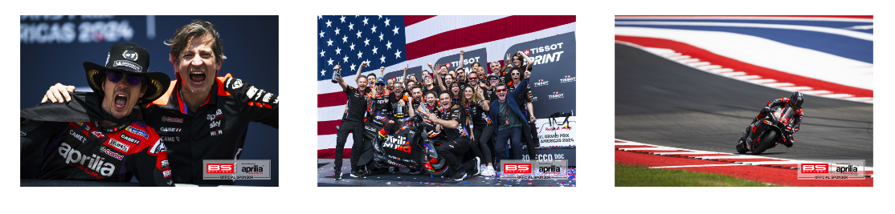On top of it, Aprilia Racing Team, powered by BS Battery, delivered a masterclass performance! Maverick Vinales took a stunning win in a race that will live long in the memory! "I'm super happy... I don't know how many overtakes I did!"

Aleix was not left out and finished in seventh place. The 29-year-old Maverick set at third in the overall standings, three points behind Martin's lead and Bastianini. The stage is set for an electrifying season ahead.

While Fabio Quartararo faced adversity, his resilience shone through as he surged from P20 to P12, showcasing his unwavering determination amidst stiff competition.

Looking ahead, both Fabio and the Aprilia Racing Team will be back in action in two weeks' time for the Gran Premio de España, held at the Circuito de Jerez – Ángel Nieto from 26-28 April.

For BS Battery, the Americas Grand Prix was more than a race; it was an intense moment of collaboration and enduring passion for motorsports, on and off the track.