**Junior Team Suzuki LMS and BS BATTERY: Inspiring Tomorrow's Mechanics for the 2024 Season!**

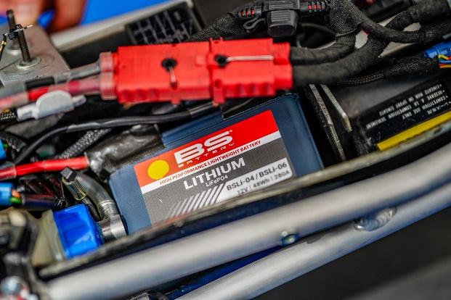As the excitement builds for the opening round of the French Superbike championship at Le Mans on April 6 & 7, 2024, our eyes are on the [**Junior Team Suzuki LMS**](https://bs-battery.com/2021/09/junior-team-suzuki-lms/), powered by BS Battery. This dynamic partnership between the young mechanics students of the Junior Team Suzuki LMS and the support of BS Battery promises an electrifying season ahead!

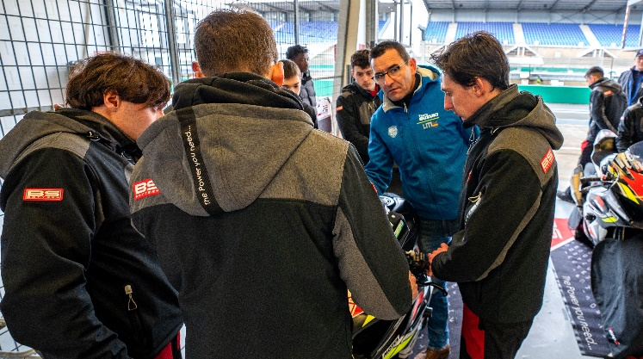

Since 2022, BS Battery has been an Official Technical Partner of the Junior Team Suzuki LMS, aiding their position in both the French national Superbike championship and the endurance world championship, notably the prestigious 24 hours of Motos at Le Mans. The collaboration sees BS Battery's cutting-edge [**BSLi-04/06 lithium battery**](https://bs-battery.com/product/bsli-04-06/) technology integrated into the Suzuki 1000 GSX-RR road motorcycles, enhancing performance with its lightweight design.

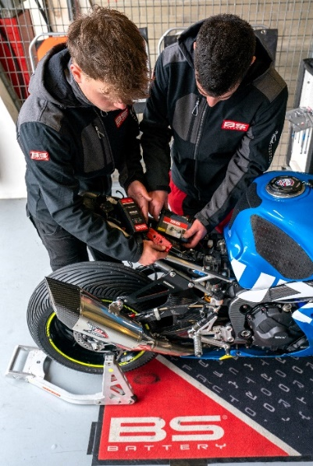

Run by **Damien Saulnier**, a former student turned teacher and now esteemed team manager, the program is part of an educational institution dedicated to nurturing young talent in motorcycle racing. It stands as a beacon of excellence, attracting over 50 to 70 applications annually, from which only 10 fortunate students are selected to embark on a year-long intensive training program. With a rich history spanning 28 years, the team boasts an impressive track record, including over 15 championship titles and a legacy of over 80 pilots and 280 mechanics.

BS Battery's involvement extends beyond mere sponsorship, actively supporting the team with essential equipment and fostering invaluable learning experiences to empower the next generation of motorsport enthusiasts and professionals.

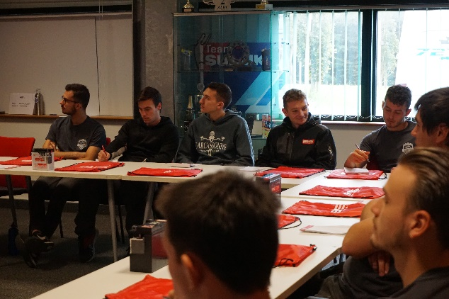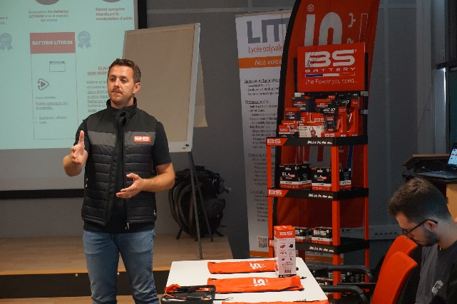

***BS Battery Academy - Le Mans Sud high school – October 2023***

As the French Superbike championship gears up for another thrilling season, featuring over 200 drivers across seven categories and 14 races per weekend, the stage is set for the young team to make their mark. Once again, the FSBK will take place on seven of the most beautiful French circuits, starting with the legendary Bugatti track at Le Mans (72). The championship will then be set on the circuits of Lédenon (30), Nogaro (32), Magny-Cours (58), Pau Arnos (64), and Carole (93) before playing its final on the Paul Ricard track (83).

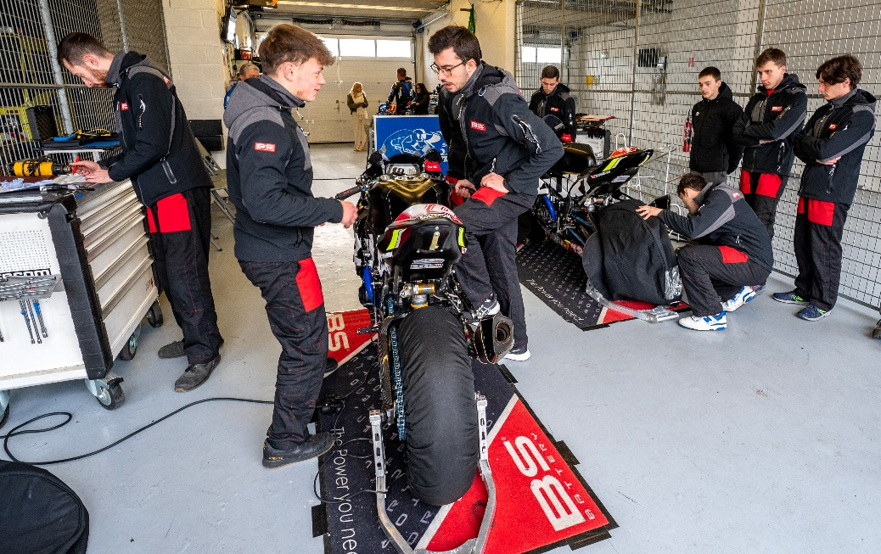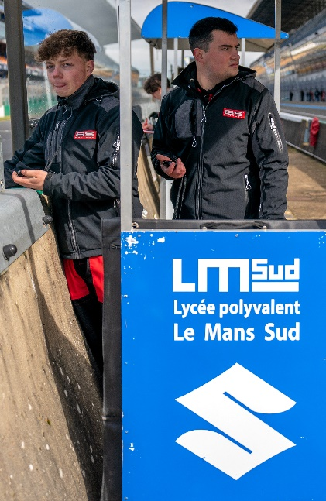

Looking ahead to this season, both the new 2024 promotion and BS Battery set ambitious goals, with aspirations to shine in the Superstock category in endurance and the Challenger category in the French Superbike championship.

Amidst the adrenaline-fueled action and intense competition, Bs Battery is glad to be alongside the Junior Team Suzuki LMS and to perpetuate the racing passion in the younger generations.

To all our new young riders, as you prepare to embark on this challenge, BS Battery believes in you. Go forth with passion, confidence, and determination, and enjoy the ride! We can't wait to see you on the track!