Thrilling Launch of the ipone Continental Cup 2024 in Pau
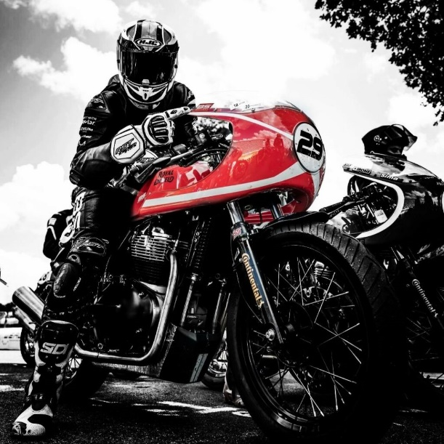
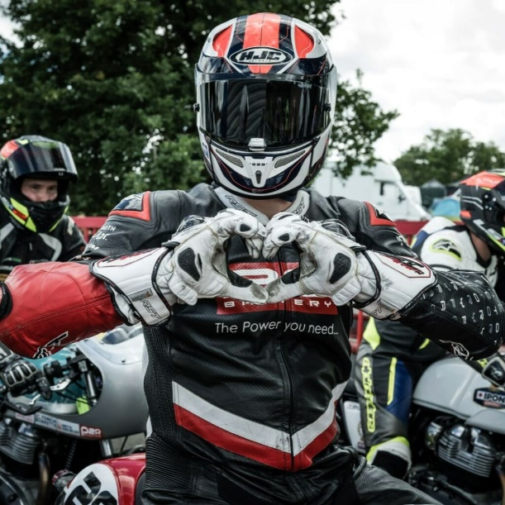
This weekend marks the return of the 1st event of the Ipone Continental Cup!

The season's kickoff in Pau delivered just that, combining high-speed excitement with a unique human dimension. Julien, riding his red Continental GT in the colors of BS BATTERY, number #29, delivered an impressive performance. Out of 46 riders, he achieved 6th place overall in the scratch category and 4th in his class, highlighting his exceptional skills and embodying the Cup's spirit of friendliness and camaraderie.
This year's edition not only fuels participants' passion for motorcycling but also enhances the competition with a warm, communal atmosphere. As the season progresses, both riders and spectators can anticipate many more exhilarating and heartwarming moments.
We are thrilled to be part of this vibrant event, especially with Julien's strong presence, and look forward to the next round at the Navarra circuit from June 14 to 16. We can't wait to see what's next!
