**High Side Festival: A weekend of passion and 300 batteries tested by BS Battery!**

French video*– Retour sur l’Highside Ride Festival avec BS Battery (Passage de 8’15 à 9’37):* [*link*](https://youtu.be/L0wFsU-hEPY)

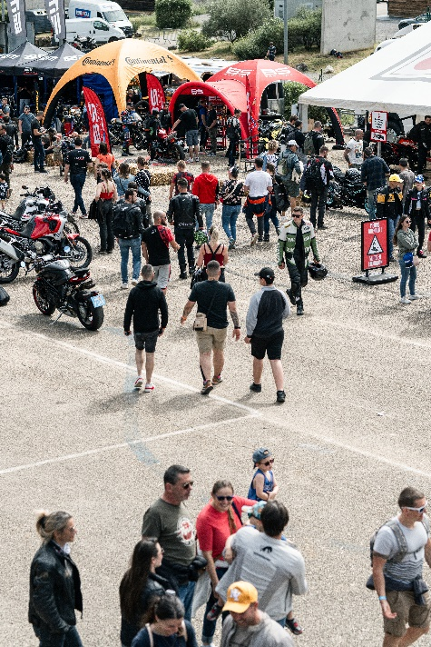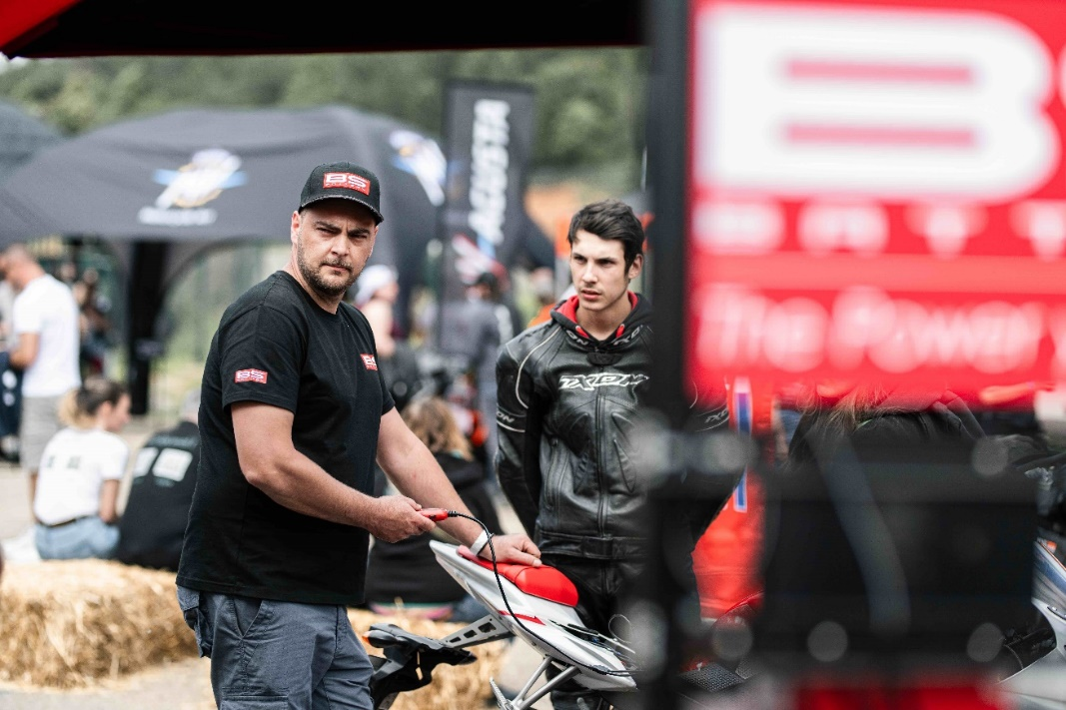

The High Side Festival, held last weekend from May 31 to June 2 at the Pôle Mécanique Alès-Cévennes, was a roaring success, marking the third edition of this thrilling motorcycle festival. With a mission to ignite the passion for motorcycle riding in both seasoned riders and curious newcomers, there was something for everyone, from racing on the speed track to participating in road improvement stages. The maintenance corner, centrally located within the festival, featured our BS Battery team, dedicated to ensuring every rider could enjoy the festival in peak condition.

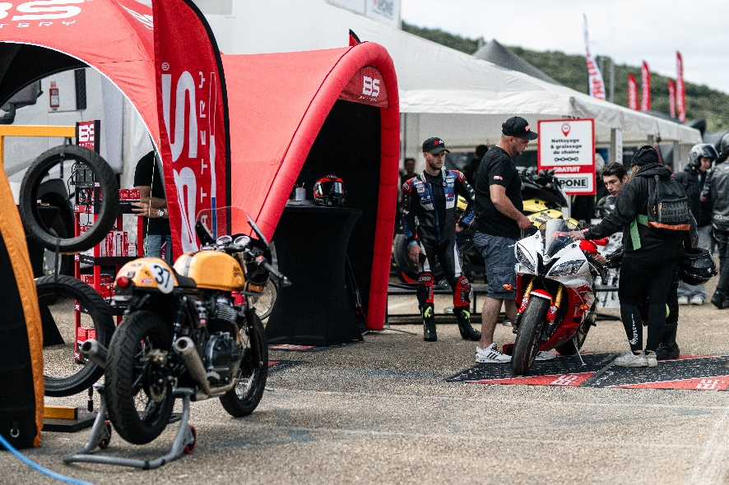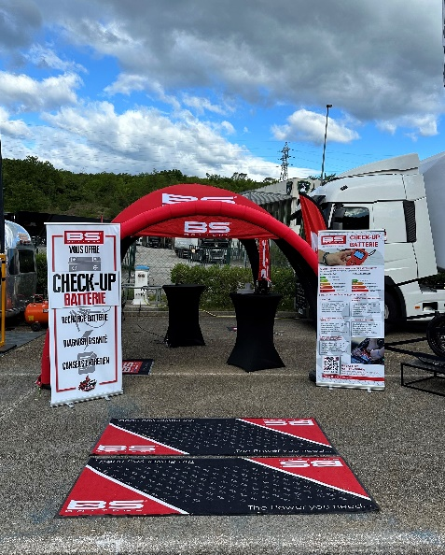

Our colleagues, Julien, European key account manager, and Regis, professional mechanic, were at the heart of the action, providing invaluable services and expert advice. At our station, riders could get a comprehensive check-up of their bikes' batteries free of charge. The first step in our process involved using our [BST1000](https://bs-battery.com/product/bst-1000/) tester to evaluate each battery. Riders could observe the testing process firsthand, gaining insights into the health of their batteries.

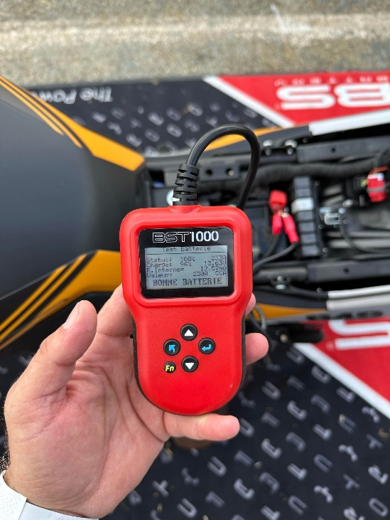

Thanks to its complete testing program (battery test, cranking test, charging test, and print), the BST1000 tester performed a full analysis, including a Cold Cranking Amps (CCA) check, voltage control, and an assessment of the internal resistance, which indicates the wear and tear on the battery. After the test, each rider received a detailed report outlining the battery's state of health and tailored advice on maintenance practices to extend battery life. Along with this valuable information, we also handed out some special gifts!

Throughout the three-day festival, we tested approximately 300 batteries, engaging with the community and sharing our expertise. The interaction was not only beneficial for the riders but also a lot of fun for us. The enthusiasm and energy of the attendees made the event truly special.

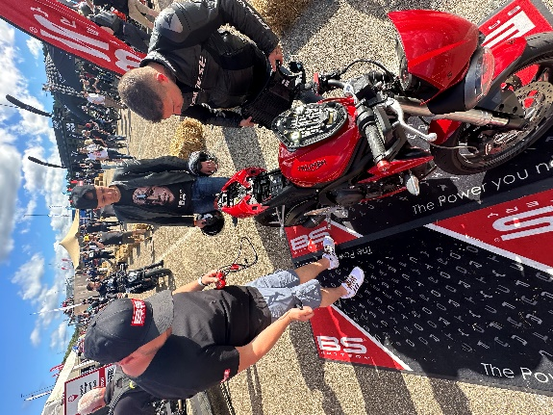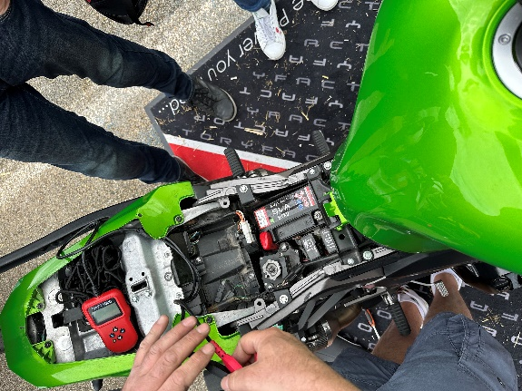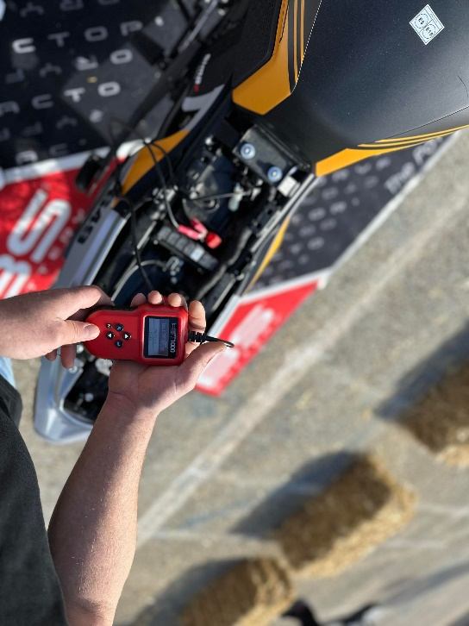

We extend our thanks to everyone who visited our booth and to the organizers of the High Side Festival for creating such an experience. We look forward to participating in future editions and continuing to support the motorcycle community with our expertise and passion.

Until next time, ride safe and keep your batteries charged!