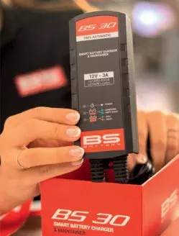
High-powered bike- specific SLA Max BGZ Series batteries

French battery specialist BS Battery is offering dealers five new Sealed Lead Acid (SLA) batteries for large displacement touring model applications, providing up to 20% more Touring model power.
Part of the company's SLA Max range, these latest generation, factory-activated BGZ batteries are designed specifically for the high cranking amp requirements of high-powered Touring models.
Features include built-in copper nuts on the terminal to enhance conductivity by up to 50% more than a standard terminal and improve torque, and taller
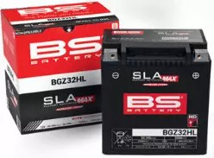
plates for more starting power.
The company says that "the new design and materials combination means something like the BGZ battery is able to keep a Touring bike powered even when it is loaded up with electronic accessories that draw from the battery, such as a GPS or phone charger.
"Our ready to use factory-activated BGZ batteries are maintenance-free and non-spillable.They are the most powerful models in our award-winning SLA Max range with a starting power, life cycle and capacity of up to 20% greater than standard SLA battery technology".
That makes them ideal for big bore V-twin as well as Japanese and European manufacturer 'metrics' and forATVs and UTV powersports applications. BS Battery says it also has a full range of BGZ/SLA Max compatible chargers and conditioners - such as the pro-grade 'Connect and Forget' BS30, which "can easily serve batteries with up to 60 Ah and 120 Ah (for maintenance), which makes it ideal for larger bikes". Additional features include a multi-axis hook.
It is one of five smart chargers in a range that also includes its sophisticated, reconditioning function-

equipped BK20 three-bank smart charger - for simultaneous charging and maintenance of different battery voltages and technologies.
BS BATTERY 
Paris, FRANCE
Tel: +33 1 83 62 45 60
sales@bs-battery.com www.bs-battery.com

