**P R O D U C T S H O W C A S E**

Touring Power

**BATTERIES**

Robust Batteries for Big Bikes

lanning a long-distance trip on a Touring bike takes a lot of work, and there are plenty of things to consider when getting ready to hit the road. One thing riders shouldn’t have to worry about,

P

though, is whether their battery can go the distance. Thanks to the new BGZ Batteries from BS Battery, Touring bikes can put on the kilometers without the worry.

The new BGZ Series batteries are part of the SLA Max range from BS Battery. These 5 new SLA (Sealed Lead Acid) battery models are specifically designed to meet the performance needs of high-powered Touring models.

Each of these latest-generation activated AGM batteries includes built-in copper nuts on the terminal, which en- hances connectivity up to 50 percent more than a standard terminal. This copper connection can improve torque, as well. Another design feature is taller plates, which give bikes even more starting power.

BS Battery also has a full range of chargers to keep batteries fresh and ready to go. The BS30 Charger (p/n 3807-0706) is one of the five smart chargers in the line, which includes options for both riders and professionals, such as the BK20. The sophisticated BK20 is a three-bank smart charger that is able to charge and maintain differ- ent voltages or technologies at once, and it includes a reconditioning function.

The BS30 charger is a “connect and forget” design. Once connected, this 12V, 3A charger will automatically detect whether the battery is Lead Acid or Lithium based. All the

**The new BGZ Series batteries are part of the SLA Max range from BS Battery, and are specifically designed to meet the performance needs of high-powered Touring models. They’ll even keep a Touring bike going when it’s loaded up with electronic accessories.**

**BS Battery’s BS30 Charger is a “connect and forget” design. Once connected, this 12V, 3A charger will automatically detect whether the battery is Lead Acid or Lithium based. All the user has to do is connect the charger. The charger handles everything else.**

This new design and materials combination means that the 12V BGZ Battery (p/n 2113-0934) is able to keep a Touring bike going, even when it is loaded up with elec- tronic accessories that also pull from the battery, like a GPS or phone charger.

Each BGZ Battery arrives ready to use since it is factory ac- tivated, and they are maintenance-free and non-spillable. These new Touring-specific batteries are the most power- ful models in the SLA Max range. In fact, BS Battery reports they have starting power, cycle life and capacity that is up to 20 percent higher than its standard SLA range. That makes them ideal for big-bore V-Twin and Metric motor- cycles, but they are also a great choice for ATVs and UTVs.

user has to do is connect the charger. The charger handles everything else.

The adaptable charging algorithm eliminates any chance of overcharging. The BS30 has a multi-axis hook for easy hanging, and it can easily serve batteries with up to 60Ah and 120Ah (for maintenance), which makes it ideal for larger bikes.

In addition to European plugs, the BS Battery chargers are also now available with a UK power plug. ■

**» *Talk to your Parts Europe rep to learn more about BS Battery products. You can find them all in the Tires, Tools***

***& Chemicals catalog, and at*** [***www.partseurope.eu.***](http://www.partseurope.eu/)

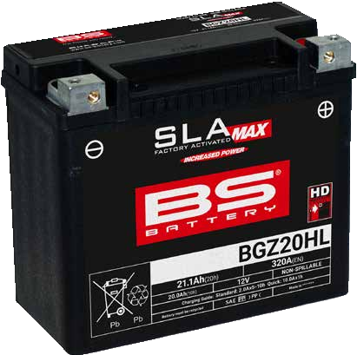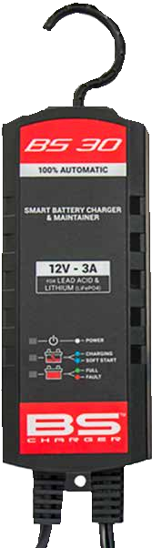

**44 PARTS EUROPE** MAGAZINE ★ S U M M E R 2 0 2 4 • • • • • • • • • • • • • • • • • • • • • • • • • • • • • • • • • • • • • • • • • • • • • • • • • • • • • • • • • • • • • • • • • • • •