15 years of BS Battery

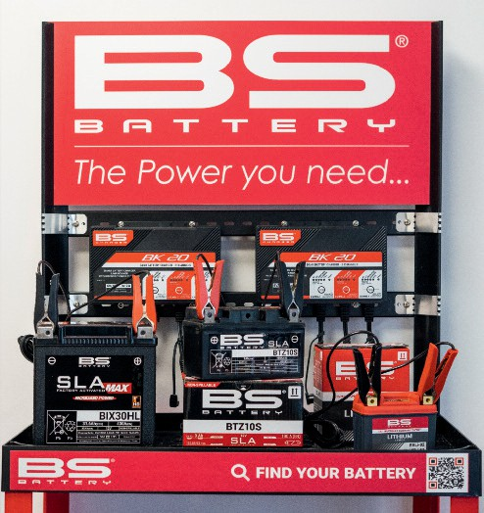

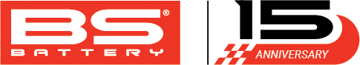

Founded in Paris by battery industry veteran Alain Sebban, and headed up since 2009 by his son Benjamin Sebban as General Manager, BS Battery has come a long way in a short time.

Alain's founding vision was clear - to be the first powersports industry battery manufacturer to offer the widest possible range of high-quality battery and care solutions for specialist sectors in an already competitive and overpopulated sector at that time.

Since then, of course, the changes in technology and market direction seen in the powersports battery sector have made it even more challenging, which makes the success achieved in those 15 years even more impressive.

The introduction of smart chargers line in 2011 was the first step in taking the BS Battery brand's service-oriented approach into the adjacent market opportunities, while addressing the increasingly complex issues and importance of charging and maintenance.

The launch of the SLA (Sealed Lead Acid) battery range in 2014 confirmed a reputation for innovation with ready- to-use ‘plug and play’ solutions that are designed to simplify the user experience.

In 2015, the company unveiled its SLA MAX range, offering the kind of higher power capacity and starting amps that large displacement V-twin and touring model engines require, with lithiums coming two years later.

In 2016, BS Battery started to forge strong collaborations with OEMs (Original Equipment Manufacturer) approved by leadingmotorcycle brands

**Alain Sebban, founder with Benjamin Sebban, General Manager**

**European Warehouse - Arles (France)**

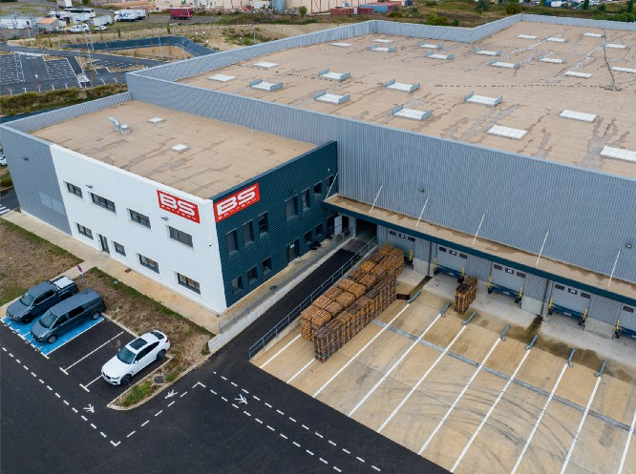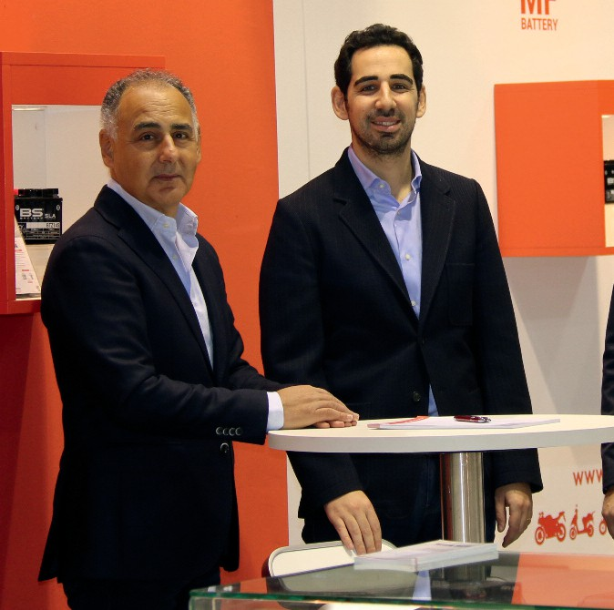

worldwide.

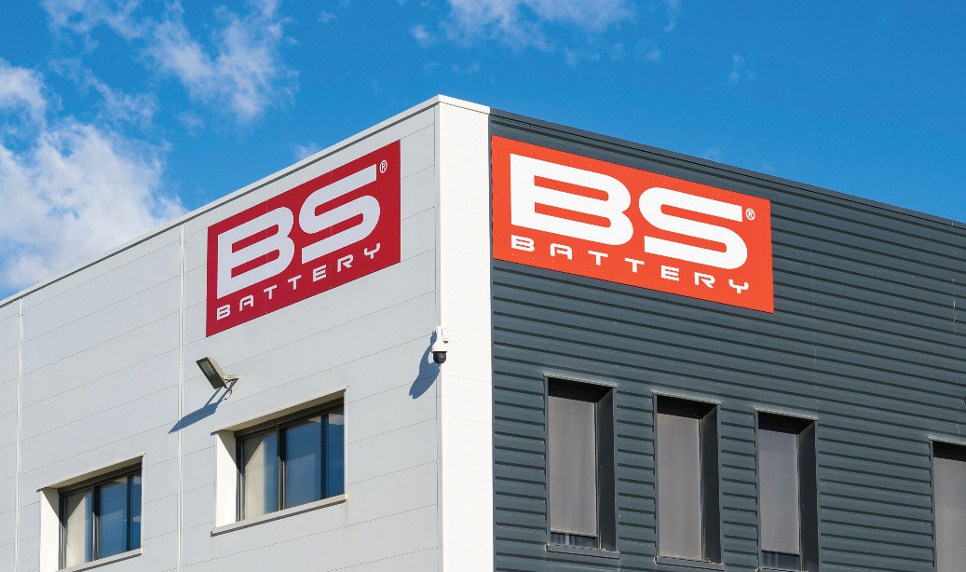

**Headquarters - Arles (France)**

2017 saw BS Battery expand its global footprint by establishing offices in Japan, with its first fully automated OEM production line started a year later. The 2018 partnership with MotoGP rider Johann Zarco marked BS Battery's entry into racing and further elevated the brand's profile in the racing and OEM communities.

The sponsorship of rising stars like Fabio Quartararo in 2019 further

deepened its commitment to motorsport, culminating in the celebration of his Moto GP Championship title in 2021.

In 2020, BS Battery became the Official Sponsor of World Superbike GMT94 Yamaha Team. "Additionally, our partnership with the Kawasaki Bud Racing Team in MXGP has provided us with valuable insights for the off-road segment.

"The following year saw us establish an additional production plant and subsidiary in Vietnam. In addition, becoming the Official Sponsor of Sherco Racing Team highlighted BS Battery’s support for diverse motorsport disciplines, from Enduro to Rally.

"In 2022, we established a new

**Official Sponsor Aprilia Racing MotoGP**

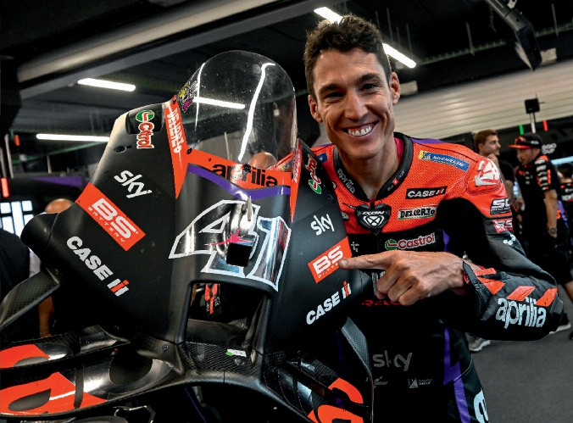

European warehouse in Arles, in France, and the launch of our North American subsidiary has opened new market opportunities.

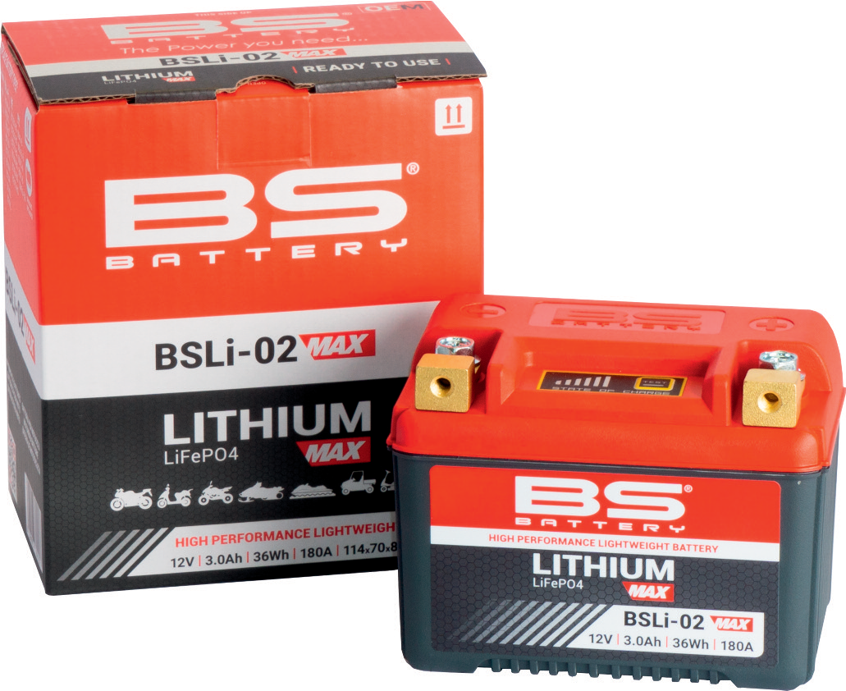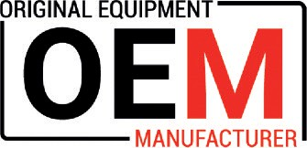

**New range LITHIUM MAX to meet the new standards**

"Having established offices in the

**Fabio Quartararo**

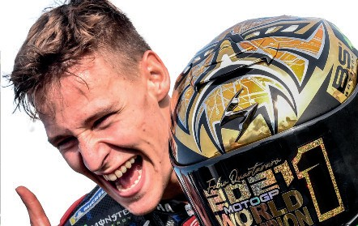

Middle East and Latin America, in 2023 we strengthened our commitment to MotoGP by becoming the Official Sponsor of Aprilia Racing, extending our collaboration from road, as an Original Equipment Manufacturer, to the racing world.

"The same year also saw the launch of the new SLA MAX BGZ Series, offering the highest CCA and capacity for V- twin and ATV applications, alongside an innovative LITHIUM MAX range. "In total, we offer 400 battery solutions, distributed across 80 countries, supported by a dedicated team of 25 employees. With 15 racing partners, three subsidiaries and three coordination offices, the company continues to grow, with the two production facilities enhancing our capabilities.

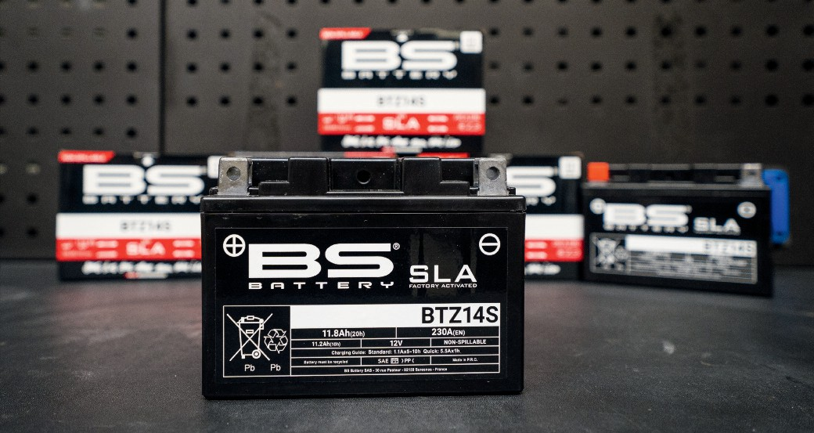

**SLA - ready to use batteries**

"So, that's not bad for the first 15 years, is it? We are looking forward to where the next 15 years take us and where it takes the fast-developing industry that we are a part of." [**www.bs-battery.com**](http://www.bs-battery.com/)

