Yamaha GMT94 Relies on BS Battery's Lithium Max

After five successful seasons of collaboration, BS Battery continues its technical partnership with the Yamaha GMT94 team managed by the ex 24H of Le Mans winner Christophe Guyot for the 2025 FIM WorldSuperbike & Supersport World Championship.

Both riders, Michael Ruben Rinaldi and Lucas Mahias, will be racing on the all- new Yamaha YZF-R9, a machine designed to deliver peak performance on every lap. For the 2025 season, Yamaha GMT94's all-new YZF-R9 will be powered by BS Battery's latest BSLi- 02 MAX lithium battery, the most advanced, high-performance solution designed specifically for racing.

BS Battery's most powerful lithium lineup, the Lithium Max offers an ultra- lightweight construction that is up to 70% lighter than traditional lead-acid batteries. It provides higher cranking power, superior capacity and durability, along with enhanced conductivity, ensuring maximum reliability even under extreme conditions. This allows the team to push performance limits on every lap. With an extensive cycle life of over 2000 cycles, these batteries are built to last. They can withstand heat resistance up to 230°C, ensuring optimal performance in demanding environments.

The robust brass terminals enhance

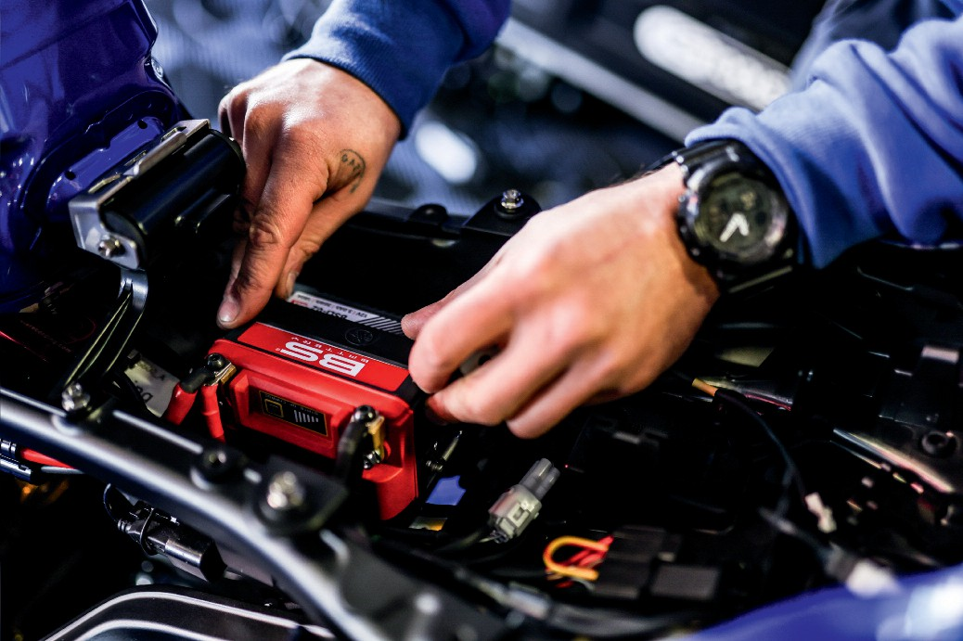

electrical performance, providing a more reliable and efficient connection. For added convenience, the state of charge indicator allows you to easily monitor the battery's charge status through the indicator screen located on top. "Whether you're on the track or in the field, the Lithium Max ensures your performance is always at its peak."

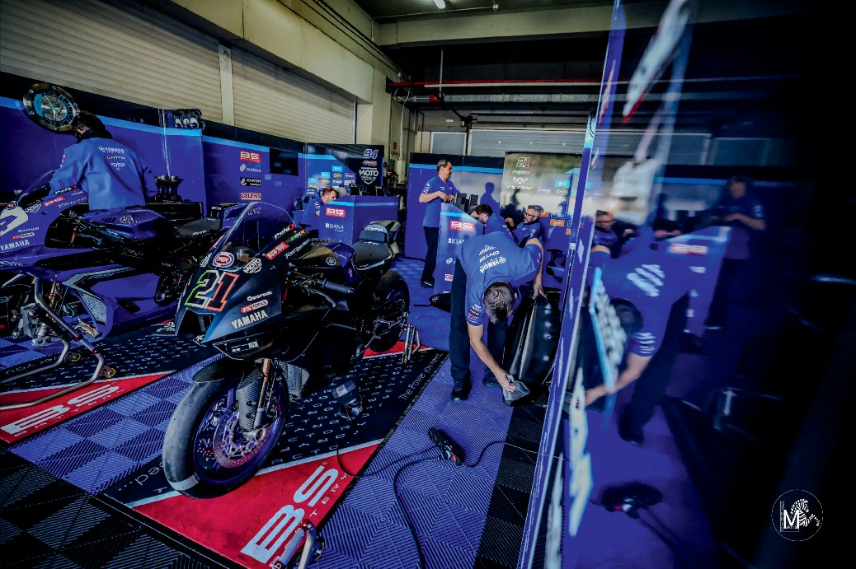

The range includes 3 models feature larger pouch cells for enhanced CCA and capacity:

BSLi-02 MAX - mainly developed for new and latest off-road bikes, with a Cold Cranking Amps (CCA) of 180 A and capacity of 3 Ah – while maintaining its famous lightness.

BSLi-10 MAX - designed to meet the

exacting specifications of modern V- twins, this reliable model features 750A (CCA) and a capacity up to 15 Ah to ensure smooth starts and consistent performance in all conditions.

BSLi-12 MAX - with a CCA of 900A, this model provides the highest cranking power available in the range, ideal for larger vehicles like ATV/UTV/SSV. With a capacity of 18 Ah, the robust pure brass terminals and durable materials make them resistant to vibration and shock.

The Lithium Max battery range is specially developed to meet the superior needs of road and off-road motorcycles, V-Twins, ATVs, UTVs, and SSVs, "making it a premium choice for the latest fitment requirements across all applications."

"Beyond batteries, Yamaha GMT94 also relies on BS Battery's BS10 Smart Charger to maintain optimal battery performance throughout race weekends. This package highlights BS Battery's commitment to delivering high-endurance energy solutions tailored for motorsport excellence." [**www.bs-battery.com**](http://www.bs-battery.com/)

